# 2018 Observing Notes

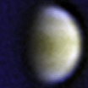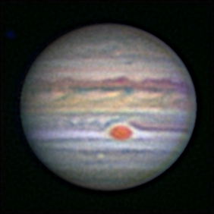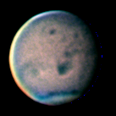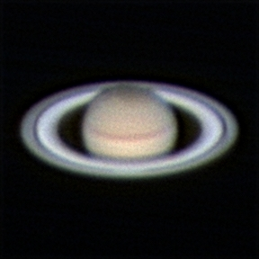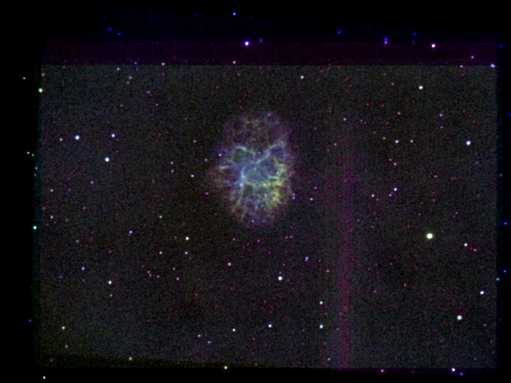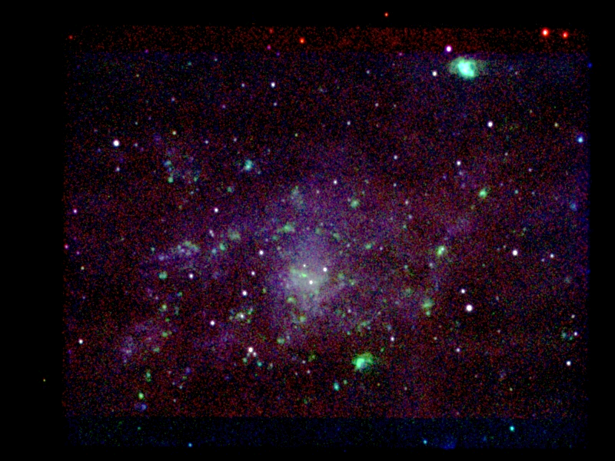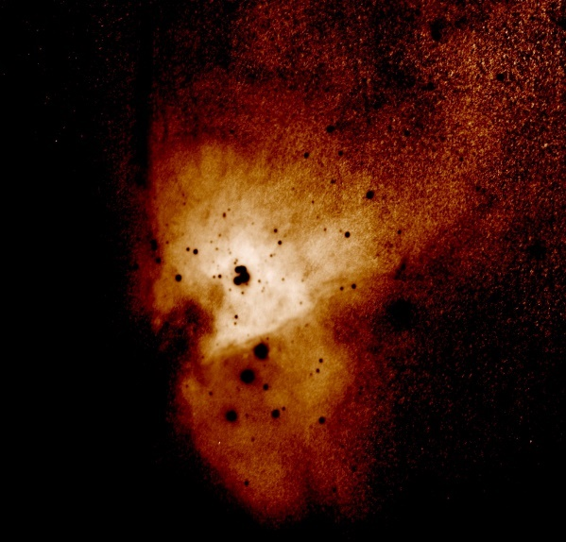

2018 Observing Notes 1

Year in Review 3

January 4

Winter 2018 Planning 4

2018-Jan-02 (Jan-03 UT): M33 SII 5

2018-Jan-04 (Jan-05 UT): M33 HIA 6

2018-Jan-07 (Jan-08 UT): M33 OIII 7

2018-Jan-11 (Jan-12 UT): M33 HIB 8

2018-Jan-16 (Jan-17 UT): M33 HIB 9

2018-Jan-17 (Jan-18 UT): M33 HIA – NE Region 10

February 12

2018-Feb-13 (Feb-14 UT): M42 NII 12

2018-Feb-17 (Feb-18 UT): M42 CH4 13

2018-Feb-18 (Feb-19 UT): M42 CH4 14

2018-Feb-24 (Feb-25 UT): M42 CH4 15

2018-Feb-25 (Feb-26 UT): M42 CH4 16

2018-Feb-26 (Feb-27 UT): M42 CH4 17

2018-Feb-27 (Feb-28 UT): M42 SII 18

March 19

Spring 2018 Planning 19

2018-Mar-06 (Mar-07 UT): M1 656HIA 20

2018-Mar-07 (Mar-08 UT): M1 658NII 21

2018-Mar-10 (Mar-11 UT): M1 501OIII 22

2018-Mar-11 (Mar-12 UT): M1 486HIB + M81 501OIII 23

2018-Mar-12 (Mar-13 UT): M1 672SII 25

2018-Mar-13 (Mar-14 UT): M1 672SII 26

April 27

2018-Apr-01 (Apr-02 UT): M81 501OIII 27

June 28

2018-Jun-04 (Jun-05 UT): Vega and Jupiter Spectra for Calibration 28

2018-Jun-11 (Jun-12 UT): Jupiter Video 29

2018-Jun-12 (Jun-13 UT): Jupiter Video 31

2018-Jun-13 (Jun-14 UT): Venus and Jupiter Video 33

Summer 2018 Planning 36

2018-Jun-25 (Jun-26 UT): Venus and Jupiter Video 37

2018-Jun-26 (Jun-26 UT): Mars Video 39

July 42

2018-Jul-09 (Jul-10 UT): Venus, Jupiter and Saturn Video 42

2018-Jul-11 (Jul-12 UT): Jupiter and Jovian Moons 46

2018-Jul-14 (Jul-15 UT): Jupiter, Saturn, and Mars Video 48

2018-Jul-17 (Jul-18 UT): Jupiter and Saturn Video 53

Analyses 55

Mars 55

Jupiter 57

Saturn 62

References 63

## Year in Review

M33 multi-spectral

M42 multi-spectral

M1 multi-spectral

Flux calibration of narrowband filters

Jupiter imaging

Stuff to do:

* Finish solar eclipse stuff
* Finish narrow band calibration
* Finish M42 analysis
* Create GRS code for size

## January

### Winter 2018 Planning

Last Updated 12/20/2017

* Observations – ~~January 20~~ February 15 first visibility times; Dark around ~~5:45pm~~ 6:30pm
  + Imaging – wide field
    - 6:30pm – M45 Pleiades
    - 6:30pm – NGC1499 California Nebula
    - 7:00pm – Simeis 147
  + Video – 4500mm
    - **7:00pm – M42** – CRGB covering the bar (2hrs?). Also, better focus. Key bands to add are 685NIR and 656HIA (2-4 hrs?)
    - 9:00pm – Castor
    - 9:30pm – Zet Cnc!!!!!!!
  + Imaging – 1260mm
    - 5:45pm – M33 – 1260mm (486HIB, 501OIII, 656HIA – NGC604 coverage, 672SII, ~~658NII~~)
    - 7:00pm – M42 – 1260mm (889CH4 – 4 hrs, ~~807NIR~~, 658NII – 1-2 hrs)
    - 7:00pm – M1 Crab Nebula – 1260mm (486HIB, 501OIII, **656HIA – 1hr?,** 672SII, 658NII) – Is there an issue with radial velocity and filter FWHM?
* Analysis
  + M31 Multispectral Analysis *ala* M33, M81, M101 etc.
  + Solar Eclipse Movies, ratio analysis, etc.
  + Questions for OPT:
    - **NII filter**
    - GoTo Mounts
    - Motorized Focuser
    - Custom Filters

### 2018-Jan-02 (Jan-03 UT): M33 SII

Last Updated 1/3/2018

Very clear – transparency =4/5. Used tube extender to protect corrector plate for C8 from frost and condensation. This did not seem to affect the flat fielding results using files that were obtained without the extender.

|  |  |
| --- | --- |
|  |  |
| M33-20180103UT-672SII-sum01h31m00s-Flattened-LogLog-HalfSize.jpg | M33-201XXXXXUT-672SII-sum02h08m00s-Flattened-LogLog-HalfSize.jpg |
|  |  |
| M33-20161XXXUT-XXX-SHO-ColBal-HalfSize-Aligned.jpg | M33-201XXXXXUT-SHO-ColBal-GaussSmooth2pix-HalfSize.jpg |

**Data Disposition:** Raw data zipped on Astronomy Laptop ready to move to the 2TB archive drive. Processed data resides on the Astrothumb3 thumb drive.

### 2018-Jan-04 (Jan-05 UT): M33 HIA

Last Updated 1/3/2018

Very clear – transparency =4/5. Used tube extender to protect corrector plate for C8 from frost and condensation.

|  |  |
| --- | --- |
|  |  |
| M33-20180105UT-656HIA-sum02h09m00s-Flattened-LogLog-HalfSize.jpg | M33-201XXXXXUT-656HIA-sum03h13m30s-Flattened-LogLog-HalfSize.jpg |
|  |  |
| M33-20161XXXUT-XXX-SHO-ColBal-Aligned-HalfSize.jpg | M33-201X-1260mm-SHO-ColBal-Smth1pix-HalfSize.jpg |

**Data Disposition:** Raw data zipped on Astronomy Laptop ready to move to the 2TB archive drive. Processed data resides on the Astrothumb3 thumb drive.

### 2018-Jan-07 (Jan-08 UT): M33 OIII

Last Updated 1/8/2018

Very clear – transparency =4/5. Used tube extender to protect corrector plate for C8 from frost and condensation.

|  |  |
| --- | --- |
|  |  |
| M33-20180108UT-501OIII-sum02h03m00s-Flattened-LogLog-HalfSize.jpg | M33-201XXXXXUT-501OIII-sum03h11m45s-Flattened-LogLog-HalfSize.jpg |
|  |  |
| M33-20161XXXUT-XXX-SHO-ColBal-Aligned-HalfSize.jpg | M33-201XXXXXUT-XXX-SHO-Smooth1pix-HalfSize.jpg |

**Data Disposition:** Raw data zipped on Astronomy Laptop ready to move to the 2TB archive drive. Processed data resides on the Astrothumb3 thumb drive.

### 2018-Jan-11 (Jan-12 UT): M33 HIB

Last Updated 1/8/2018

Very clear to start – transparency =4/5 – but clouds came in about an hour into the imaging session. Used tube extender to protect corrector plate for C8 from frost and condensation.

|  |
| --- |
|  |
| M33-20180112UT-486HIB-sum00h46m00s-Flattened-LogLog-HalfSize.jpg |

**Data Disposition:** Raw data zipped on Astronomy Laptop ready to move to the 2TB archive drive. Processed data resides on the Astrothumb3 thumb drive.

### 2018-Jan-16 (Jan-17 UT): M33 HIB

Last Updated 1/8/2018

Very clear night: Transparency ~4/5. Seeing was decent, say 3/5, but focus degraded. Best images are only through first half of the observing session. Used tube extender to protect corrector plate for C8 from frost and condensation.

|  |  |
| --- | --- |
|  |  |
| M33-20180117UT-486HIB-sum01h47m00s-Flattened-LogLog-HalfSize.jpg | M33-2018011XUT-486HIB-sum02h33m00s-Flattened-LogLog-HalfSize.jpg |

**Data Disposition:** Raw data zipped on Astronomy Laptop ready to move to the 2TB archive drive. Processed data resides on the Astrothumb3 thumb drive.

### 2018-Jan-17 (Jan-18 UT): M33 HIA – NE Region

Last Updated 1/8/2018

No recollection on the quality of the night.

|  |
| --- |
|  |
| M33NE-20180118UT-656HIA-sum01h39m30s-Flattened-LogLog-HalfSize.jpg |

**Data Disposition:** Raw data zipped on Astronomy Laptop ready to move to the 2TB archive drive. Processed data resides on the Astrothumb3 thumb drive.

## February

### 2018-Feb-13 (Feb-14 UT): M42 NII

Last Updated 2/16/2018

Very clear – transparency =4/5. Seeing was pretty good also at 3/5. This was my first use of the Astrodon 658NII filter I purchased via Astromart. I used a 656HIA flat field for calibration.

|  |
| --- |
|  |
| M42-20180214UT-658NII-sum0h52m42s-Log-HalfSize.jpg |

Preliminary analysis shows that the spatial distribution of the signal is very similar to that of 672SII. That is to be expected given the similar excitation energies of the two ions (1.844KeV for SII and 1.899Kev for NII). Very notable is the much higher signal level in the NII image versus the SII image. This is due in part to the much higher NII elemental abundance (1.12e-4) versus SII (1.62e-5) – a factor of seven difference. Thus, NII is an easy and appropriate substitute for SII in the red channel of classical false color emission line images (with OIII for blue and HIA for green). SII then takes on significant importance for another reason: The small difference in excitation energies suggests that the ratio SII/NII may server as a approximation for standard electron density plasma diagnostic ratios like SII λ671.6/λ673.1. Of course, this needs to apply to “pure line” images. It’s not clear that correcting for reddening would have any effect.

**Data Disposition:** Raw data zipped on 2TB archive drive. Processed data resides on the Astrothumb3 thumb drive.

### 2018-Feb-17 (Feb-18 UT): M42 CH4

Last Updated 2/18/2018

Very clear – transparency =4/5. Seeing was pretty good also at perhaps 3/5. This is the start of an attempt to build up SNR in the 885CH4 channel for M42. The purpose is to use this filter as a sample of the continuum seen in the wide band NIR channels that also include the strong SIII lines at 907nm and 953nm.

|  |  |
| --- | --- |
|  |  |
| M42-20180218UT-889CH4-sum01h02m30s-Flattened-Log-Gauss1pix-Stretch-HalfSize.jpg | M42-201XXXXXUT-889CH4-sum01h24m30s-Flattened-Log-Gauss1pix-Stretch-HalfSize.jpg |

**Data Disposition:** Raw data zipped on 2TB archive drive. Processed data resides on the Astrothumb3 thumb drive.

### 2018-Feb-18 (Feb-19 UT): M42 CH4

Last Updated 2/18/2018

Very clear – transparency =4/5. Seeing was pretty good also at perhaps 3/5, but then suddenly and dramatically degraded. I originally thought this was a problem with the telescope focus, but it was due to the arrival of a strong cold front.

|  |  |
| --- | --- |
|  |  |
| M42-20180219UT-0001-889CH4-sum0h16m00s-20pctNoFlat80pctHIA-Flattened-Log-HalfSize.jpg | M42-201XXXXXUT-889CH4-sum01h40m30s-Flattened-Log-HalfSize.jpg |

**Data Disposition:** Raw data zipped on 2TB archive drive. Processed data resides on the Astrothumb3 thumb drive.

### 2018-Feb-24 (Feb-25 UT): M42 CH4

Last Updated 2/18/2018

Transparency was very poor with high cirrus clouds mixed with clear holes in the clouds. Seeing was pretty good also at perhaps 3/5.

|  |  |
| --- | --- |
|  |  |
| M42-20180225UT-889CH4-sum37m30s-Flattened-Log-HalfSize.jpg | M42-201XXXXXUT-889CH4-sum02h18m00s-Flattened-Log-HalfSize.jpg |

**Data Disposition:** Raw data zipped on 2TB archive drive. Processed data resides on the Astrothumb3 thumb drive.

### 2018-Feb-25 (Feb-26 UT): M42 CH4

Last Updated 2/18/2018

Transparency was very poor with high cirrus clouds mixed with clear holes in the clouds. Seeing was pretty good also at perhaps 3/5.

|  |  |
| --- | --- |
|  |  |
| M42-20180226UT-889CH4-sum37m030s-Flattened-Log-HalfSize.jpg | M42-201XXXXXUT-889CH4-sum02h55m30s-Flattened-Log-HalfSize.jpg |

**Data Disposition:** Raw data zipped on 2TB archive drive. Processed data resides on the Astrothumb3 thumb drive.

### 2018-Feb-26 (Feb-27 UT): M42 CH4

Last Updated 2/18/2018

Transparency started out very good, 4/5, but degraded for a while (2/5) with high cirrus before improving again. Seeing was pretty good also at perhaps 3/5.

|  |  |
| --- | --- |
|  |  |
| M42-20180227UT-889CH4-sum1h07m30s_70pctNoFlat30pctHIAFlat-Log-HalfSize.jpg | M42-201XXXXXUT-889CH4-sum04h03m00s-Flattened-Log-HalfSize.jpg |

**Data Disposition:** Raw data zipped on 2TB archive drive. Processed data resides on the Astrothumb3 thumb drive.

### 2018-Feb-27 (Feb-28 UT): M42 SII

Last Updated 2/18/2018

Transparency appeared visually very good, 4/5, but signal levels seemed pretty low for the integration time. Seeing was pretty good also at perhaps 3/5.

|  |  |
| --- | --- |
|  |  |
| M42-20180228UT-672SII-sum01h01m30s-Log-HalfSize.jpg | M42-201XXXXXUT-672SII-sum3h12m00s-Log-HalfSize.jpg |

**Data Disposition:** Raw data zipped on 2TB archive drive. Processed data resides on the Astrothumb3 thumb drive.

## March

### Spring 2018 Planning

Last Updated 3/6/2018

* Observations – March 5 first visibility times; Dark around 6:30pm
  + Imaging – 1260mm
    - **10:00pm – M81** – 1260mm (486HIB, **501OIII – 4hrs,** 672SII – 6hrs, **658NII – 4hrs**)
    - **10:00pm – M82** – 1260mm (486HIB, **501OIII – 4hrs,** 672SII – 6hrs, **658NII – 4hrs**)
    - **M1** – 1260mm (486HIB, 501OIII, 672SII, 656HIA, 658NII)
  + Video – 4500mm
    - 9:00pm – Castor
    - 9:30pm – Zet Cnc!!!!!!!
    - Jupiter in early April from west pad
    - Mars in late May from west pad
    - Saturn in early May from west pad
* Analysis
  + M31 Multispectral Analysis *ala* M33, M81, M101 etc.
  + Solar Eclipse Movies, ratio analysis, etc.
  + Questions for OPT:
    - GoTo Mounts
    - Custom Filters

### 2018-Mar-06 (Mar-07 UT): M1 656HIA

Last Updated 3/7/2018

|  |
| --- |
|  |
| M01-20180307UT-656HIA-sum40m23s-Flattened-Log-HalfSize.jpg |

**Data Disposition:** Raw data zipped on 2TB archive drive. Processed data resides on the Astrothumb3 thumb drive.

### 2018-Mar-07 (Mar-08 UT): M1 658NII

Last Updated 3/7/2018

|  |  |
| --- | --- |
|  |  |
| M01-20180308UT-658NII-sum01h01m30s-NoFlat-Flattened-Log-HalfSize | M01-2018030XUT-65X-R(NII)GB(HIA)-Test-HalfSize.jpg |

**Data Disposition:** Raw data zipped on 2TB archive drive. Processed data resides on the Astrothumb3 thumb drive.

### 2018-Mar-10 (Mar-11 UT): M1 501OIII

Last Updated 3/7/2018

Need to get better flat field. Process without flat and combine weighted with flat field corrected image.

|  |  |
| --- | --- |
|  |  |
| M01-20180311UT-501OIII-sum50m30s-Flattened-Log-HalfSize.jpg | M01-201803XXUT-XXX-NHO-Test-Smoothed-BkgCol-Stretched-ColBal-Stretched-HalfSize.jpg |

**Data Disposition:** Raw data zipped on 2TB archive drive. Processed data resides on the Astrothumb3 thumb drive.

### 2018-Mar-11 (Mar-12 UT): M1 486HIB + M81 501OIII

Last Updated 3/7/2018

Okay seeing (3/5). Very bad transparency – started at 3/5, degraded to 1/5 with high cirrus.

Very unexpected appearance. Really looks like continuum rather than HI line emission. Is looks like the slope of the synchrotron emission is so steep that at 486 nm it is brighter than the HI line itself.

I definitely need more signal here. Also, NUV would be very useful for obtaining stronger synchrotron continuum.

|  |  |
| --- | --- |
|  |  |
| M01-20180312UT-486HIB-sum24m00s-Flattened-Log-HalfSize.jpg |  |

|  |  |
| --- | --- |
|  |  |
| M81-20180311UT-501OIII-sum16m00s-Flattened-Log-HalfSize.jpg | M81-20180311UT-501OIII-sum29m00s-Flattened-Log-HalfSize.jpg |

**Data Disposition:** TBD.

### 2018-Mar-12 (Mar-13 UT): M1 672SII

Last Updated 3/7/2018

Okay seeing (3/5). Very bad transparency – started at 3/5, degraded to 0/5 with low, patchy stratus.

Appearance differs more from NII than I expected. Mainly different filaments seem to be emphasized in each. Part of that could be electron density, but also part could be the doppler shifting of emission out of the narrow NII filter. A velocity map might help with that [*Charlebois et al.*, 2010].

A third effect is likely due to the cross-contamination of the NII and HI-alpha filters. Event though the SII and NII excitation energies are very similar, the SII channel is fully independent of the HI channel. For example the bright green (HI) filaments to the below center on the right side of the nebula appear yellowish in the NII-HI-OIII image due to contamination.

I need to get more signal here.

|  |  |
| --- | --- |
|  |  |
| M01-20180313UT-672SII-sum20m30s-Flattened-Log-Smoothed-HalfSize.jpg | M01-201803XXUT-XXX-SHO-Test-BkgCol-Stretched-HalfSize.jpg |

**Data Disposition:** TBD.

### 2018-Mar-13 (Mar-14 UT): M1 672SII

Last Updated 3/21/2018

Okay seeing (3/5). Good transparency 3/5.

|  |  |
| --- | --- |
|  |  |
| M01-20180314UT-672SII-sum43m00s-Flattened-Log-HalfSize.jpg | M01-2018031XUT-672SII-sum01h03m30s-Flattened-Log-HalfSize.jpg |
|  |  |
| M01-201803XXUT-XXX-SHO-Test2-Smooth-BkgSat-Stretch-HalfSize.jpg | M01-201803XXUT-XXX-SHO-Test-BkgCol-Stretched-HalfSize.jpg |

**Data Disposition:** TBD.

## April

### 2018-Apr-01 (Apr-02 UT): M81 501OIII

Last Updated 4/02/2018

Okay seeing (3/5). Good transparency 4/5.

|  |  |
| --- | --- |
|  |  |
| M81-20180402UT-501OIII-sum01h33m-Flattened-Log-HalfSize.jpg | M81-20180XXXUT-501OIII-sum02h02m-LogLog-SmoothStretch-HalfSize.jpg |

**Data Disposition:** Raw data have been zipped and are ready to be put on the 2TB archive drive.

Processed data reside on the Astronomy Thumb drive.

## June

### 2018-Jun-04 (Jun-05 UT): Vega and Jupiter Spectra for Calibration

Last Updated 10/15/2018

**VEGA**

Rotation angle is 47.36 deg clockwise computed from relative positions of zeroth and first order images of Jupiter in OIII spectra.

|  |  |
| --- | --- |
|  | VegaSpectra-20180605UT-486HIB-OPNFocus-sum500ms-RotCrop.jpg |
|  | VegaSpectra-20180605UT-486HIB-FilterFocus-sum500ms-RotCrop.jpg |
|  | VegaSpectra-20180605UT-501OIII-FilterFocus-sum500ms-RotCrop.jpg |
|  | VegaSpectra-20180605UT-658NII-FilterFocus-sum500ms-RotCrop.jpg |
|  | VegaSpectra-20180605UT-672SII-FilterFocus-sum500ms-RotCrop.jpg |
|  | VegaSpectra-20180605UT-550OPN-OPNFocus-sum500ms-RotCrop.jpg |
|  | VegaSpectra-20180605UT-550OPN-FilterFocus-sum500ms-RotCrop.jpg |

**JUPITER**

**JOVIAN MOONS**

Moons visible, from east to west (bottom to top) are Io, Ganymede, and Callisto. Further to the east of Io is the 7.8mV K2/3III giant star HD 131046.

**Data Disposition:** Raw data is zipped on Astronomy Laptop and ready for archive on 2TB drive. Processed data is in appropriate project directories on the Astronomy thumb drive.

### 2018-Jun-11 (Jun-12 UT): Jupiter Video

Last Updated 6/12/2018

|  |  |  |  |  |  |
| --- | --- | --- | --- | --- | --- |
| **Video File** | **Exposure** | **Gain** | **Gamma** | **Binning** | **Capture Area** |
| 2018-06-12-0454_2-Jupiter_650RED.avi | 0.05 | 50 | 50 | 2 | 640x480 |
| 2018-06-12-0456_3-Jupiter_550GRN.avi | 0.05 | 50 | 50 | 2 | 640x480 |
| 2018-06-12-0457_9-Jupiter_550GRN.avi | 0.03 | 50 | 50 | 2 | 640x480 |
| 2018-06-12-0459_6-Jupiter_450BLU.avi | 0.05 | 50 | 50 | 2 | 640x480 |
| 2018-06-12-0501_4-Jupiter_685NIR.avi | 0.04 | 50 | 50 | 2 | 640x480 |
| 2018-06-12-0504_4-Jupiter_807NIR.avi | 0.15 | 50 | 50 | 2 | 640x480 |
| 2018-06-12-0508_2-Jupiter_889CH4.avi | 1.5 | 100 | 50 | 2 | 640x480 |
| 2018-06-12-0515_6-Jupiter_380NUV.avi | 1 | 100 | 50 | 2 | 640x480 |

There was a lot of high haze/smoke, probably from a fire in southwest Colorado. Transparency 2/5. Seeing was hard to assess because so few stars were visible. I’d guess 3/5. I used 2x2 binning for 0.35” pixel sampling along with a cropped view of 640x480 pixels (320x240 after binning) to decrease exposure times and increase sample rate. Given that I’ve resolved sub-arcsecond features previously (0.5”?), this is probably under sampling. However, it did give the NUV and CH4 images higher quality with 1.0 sec and 1.5 second exposures, as opposed to 4 second exposures unbinned. I think the 807 channel also benefitted. See the exposure durations below.

Due to the poor resolution not to many identifiable features are seen. In the south, white oval A3 is detectable, but only in the tri-color NIR image near the west limb.

|  |  |
| --- | --- |
|  |  |
| 2018-06-12-0457_2-Hill-Jupiter-RGB-2x-ClrSmth-Wavelets-WhtBal.png | 2018-06-12-0500_0-Hill-Jupiter-807-685-RED-ClrSmth-WhtBal-Sat180pct-Wavelets.png |
|  |  |
| 2018-06-12-0507_2-Hill-Jupiter-889-550-380-2x-ClrSmth-WhtBal-Wavelets.png | 2018-06-12-0506_0-Hill-Jupiter-807-550-380-2x-ClrSmth-WhtBal-Wavelets.png |

|  |  |  |  |  |  |
| --- | --- | --- | --- | --- | --- |
| **Video File** | **Exposure** | **Gain** | **Gamma** | **Binning** | **Capture Area** |
| 2018-06-12-0510_4-Dark_889CH4.avi | 1.5 | 100 | 50 | 2 | 640x480 |
| 2018-06-12-0517_5-Dark_380NUV.avi | 1 | 100 | 50 | 2 | 640x480 |

**Data Disposition:** Processed data reside on the Astronomy Thumb drive. Raw data have been zipped and located on the 2TB archive drive.

### 2018-Jun-12 (Jun-13 UT): Jupiter Video

Last Updated 6/12/2018

The sky was somewhat more transparent than yesterday, but still with smoke and haze. Maybe a transparency of 2.5/5. Seeing was hard to judge, but about the same as yesterday, perhaps 3/5.

|  |  |  |  |  |  |
| --- | --- | --- | --- | --- | --- |
| **Video File** | **Exposure** | **Gain** | **Gamma** | **Binning** | **Capture Area** |
| 2018-06-13-0336_1-Jupiter_550GRN.avi | 0.1 | 50 | 50 | 1 | 640x480 |
| 2018-06-13-0338_7-Jupiter_450BLU.avi | 0.15 | 50 | 50 | 1 | 640x480 |
| 2018-06-13-0341_1-Jupiter_650RED.avi | 0.15 | 50 | 50 | 1 | 640x480 |
| 2018-06-13-0345_3-Jupiter_685NIR.avi | 0.15 | 50 | 50 | 1 | 640x480 |
| 2018-06-13-0348_3-Jupiter_807NIR.avi | 0.15 | 50 | 50 | 2 | 640x480 |
| 2018-06-13-0350_5-Jupiter_807NIR.avi | 0.15 | 50 | 50 | 2 | 640x480 |
| 2018-06-13-0354_7-Jupiter_889CH4.avi | 1.5 | 100 | 50 | 2 | 640x480 |
| 2018-06-13-0402_5-Jupiter_380NUV.avi | 0.6 | 100 | 50 | 2 | 640x480 |
| 2018-06-13-0412_2-Jupiter_380NUV.avi | 0.6 | 100 | 50 | 2 | 640x480 |
| 2018-06-13-0419_2-Jupiter_889CH4.avi | 1.5 | 100 | 50 | 2 | 640x480 |
| 2018-06-13-0423_5-Jupiter_807NIR.avi | 0.15 | 50 | 50 | 2 | 640x480 |
| 2018-06-13-0426_0-Jupiter_685NIR.avi | 0.15 | 50 | 50 | 1 | 640x480 |
| 2018-06-13-0429_9-Jupiter_650RED.avi | 0.15 | 50 | 50 | 1 | 640x480 |
| 2018-06-13-0432_3-Jupiter_550GRN.avi | 0.08 | 50 | 50 | 1 | 640x480 |
| 2018-06-13-0435_0-Jupiter_450BLU.avi | 0.1 | 50 | 50 | 1 | 640x480 |

The GRS is obvious in these images. Far to the east in the STR is white oval A5. Tiny A5a is not visible in the combined images below, but is visible in the later image series taken (0412-0435UT). Far to the south of the GRS is S4-LRS-1.

To the north of the GRS, in the NEB is WS-x, though an unnamed dark barge to the east is more noticeable in visible images. Near the west limb and to the far north is NN-WS-4.

|  |  |
| --- | --- |
|  |  |
| 2018-06-13-0405_5-RGBCombined-Wavelets.jpg | 2018-06-13-0405_9-Jupiter-807-685-RED-Combined-Wavelets.jpg |
|  |  |
| 2018-06-13-0406_1-Hill-Jupiter-889-GRN-NUV-Combined-Wavelets.jpg | 2018-06-13-0406_0-Jupiter-807-GRN-NUV-Combined-Wavelets.jpg |

|  |  |  |  |  |  |
| --- | --- | --- | --- | --- | --- |
| **Video File** | **Exposure** | **Gain** | **Gamma** | **Binning** | **Capture Area** |
| 2018-06-13-0357_6-Dark_889CH4.avi | 1.5 | 100 | 50 | 2 | 640x480 |
| 2018-06-13-0405_0-Dark_380NUV.avi | 0.6 | 100 | 50 | 2 | 640x480 |

**Data Disposition:** Processed data reside on the Astronomy Thumb drive. Raw data have been zipped and located on the 2TB archive drive.

### 2018-Jun-13 (Jun-14 UT): Venus and Jupiter Video

Last Updated 6/14/2018

Transparency was significantly improved, but not ideal, 3/5. Seeing was decent despite wind at 3/5.

I achieved decent Venus resolution using 2x2 binning and very short exposures. This was in spite of the fact that Venus was only 14.1 arc-sec in diameter and only about 30 degrees above the horizon in average seeing.

UV‑bright polar clouds are clearly visible. There is also a dark band just north of the equator extending from the terminator toward the limb.

|  |  |  |  |  |  |
| --- | --- | --- | --- | --- | --- |
| **Video File** | **Exposure** | **Gain** | **Gamma** | **Binning** | **Capture Area** |
| 2018-06-14-0214_3-Venus_380NUV.avi | 0.05 | 50 | 50 | 2 | 640x480 |
| 2018-06-14-0215_4-Venus_380NUV.avi | 0.05 | 50 | 50 | 2 | 640x480 |
| 2018-06-14-0218_3-Venus_889CH4.avi | 0.05 | 50 | 50 | 2 | 640x480 |
| 2018-06-14-0219_3-Venus_889CH4.avi | 0.05 | 50 | 50 | 2 | 640x480 |
| 2018-06-14-0230_5-Venus_550GRN.avi | 0.0008 | 50 | 50 | 2 | 320x240 |

|  |  |  |
| --- | --- | --- |
|  |  |  |
| 2018-06-14-0216_9-Venus_CH4+NUV.png | 2018-06-14-0216_9-Venus_CH4+RGB-L(CH4)RGB.png | 2018-06-14-0216_9-Venus_CH4+NUV-L(NUV)RGB.png |
|  |  |  |
| 2018-06-14-0221_3-Venus_CH4-GRN-NUV.png | 2018-06-14-0221_3-Venus_CH4-GRN-NUV-L(CH4)RGB.png | 2018-06-14-0221_3-Venus_CH4-GRN-NUV-L(NUV)RGB.png |

Oval BA is visible in the STR, directly north of white oval A8. To the left of A8 is A1, though a large white smear dominates the area. Further to the left is A2. To the ease, near the limb, is A7. S4-AWO-2 is just visible, far to the south and a bit to the right of A8.

White Spot Z (WSZ) is visible north of the NEB just to the right of the central meridian. Farther to the north and west is the white spot NN-WS-6. A unidentified dark spot is visible to the north and east of NN-WS-6. All identifications are from the [Jupiter in 2018, Report no. 5](https://www.britastro.org/node/14405).

|  |  |  |  |  |  |
| --- | --- | --- | --- | --- | --- |
| **Video File** | **Exposure** | **Gain** | **Gamma** | **Binning** | **Capture Area** |
| 2018-06-14-0345_0-Jupiter_550GRN.avi | 0.08 | 50 | 50 | 1 | 640x480 |
| 2018-06-14-0347_5-Jupiter_450BLU.avi | 0.1 | 50 | 50 | 1 | 640x480 |
| 2018-06-14-0351_3-Jupiter_650RED.avi | 0.15 | 50 | 50 | 1 | 640x480 |
| 2018-06-14-0355_5-Jupiter_685NIR.avi | 0.15 | 50 | 50 | 1 | 640x480 |
| 2018-06-14-0358_5-Jupiter_807NIR.avi | 0.15 | 50 | 50 | 2 | 640x480 |
| 2018-06-14-0402_8-Jupiter_889CH4.avi | 1.5 | 100 | 50 | 2 | 640x480 |
| 2018-06-14-0411_2-Jupiter_380NUV.avi | 0.5 | 100 | 50 | 2 | 640x480 |

|  |  |
| --- | --- |
|  |  |
| 2018-06-14-0347_9-Hill-Jupiter-RGB-ClrSmth-WhtBal-Wavelets-HalfSize.jpg | 2018-06-14-0355_1-Hill-Jupiter-807-685-RED-ClrSmth-WhtBal-Sat130pct-Wavelets-HalfSize.jpg |
|  |  |
| 2018-06-14-0359_7-Hill-Jupiter-889-GRN-NUV-ClrSmth-WhtBal-Wavelets-HalfSize.jpg | 2018-06-14-0358_2-Hill-Jupiter-807-GRN-NUV-ClrSmth-WhtBal-Wavelets-HalfSize.jpg |

|  |  |  |  |  |  |
| --- | --- | --- | --- | --- | --- |
| **Video File** | **Exposure** | **Gain** | **Gamma** | **Binning** | **Capture Area** |
| 2018-06-14-0405_8-Dark_889CH4.avi | 1.5 | 100 | 50 | 2 | 640x480 |
| 2018-06-14-0413_7-Dark_380NUV.avi | 0.5 | 100 | 50 | 2 | 640x480 |

**Data Disposition:** Processed data reside on the Astronomy Thumb drive. Raw data have been zipped and located on the 2TB archive drive.

### Summer 2018 Planning

Last Updated 3/6/2018

* Observations – March 5 first visibility times; Dark around 6:30pm
  + Spectra – 135mm
    - Jupiter – spectra (135mm)
    - Saturn – spectra (135mm)
  + Spectra – 1260mm
    - Jovian Moons – spectra
    - Titan – spectra
  + Video – 4500mm
    - Jupiter – All longitude coverage, multispectral
    - Jupiter – Weather coverage
    - **Saturn** – High resolution: Polar **Hexagon**, **rings details**, **north polar storms**. What is the best spectral band for the hexagon, NIR? Can I detect it if I use 2x2 binning?
    - Titan – photometry with orbital variations (is this 1260mm or 4500?)
    - Photometry tests with ASI120MM – Titan, Jovian Moons, Stars (Vega?) with gain, gamma and exposure variations
    - Mars – full NIR longitude coverage for mapping
    - Mars – full seasonal coverage for polar cap development and recession
    - **Mars** – **dust storm evolution**, other clouds
    - **Mars** – **Phobos and Deimos**
* Analysis
  + Update Mars report to modern format
  + Update Jupiter analysis and report including: better analysis coverage over apparitions, Python code for GRS size analysis, white oval analysis, and meridional wind analysis.
  + Update Saturn analysis and report.
  + M31 Multispectral Analysis *ala* M33, M81, M101 etc.
  + M81 reanalysis with 501OIII data
  + Solar Eclipse Movies, ratio analysis, etc.
  + Questions for OPT:
    - GoTo Mounts
    - Custom Filters

### 2018-Jun-25 (Jun-26 UT): Venus and Jupiter Video

Last Updated 6/14/2018

|  |  |  |  |  |  |
| --- | --- | --- | --- | --- | --- |
| Video File | Exposure | Gain | Gamma | Binning | Capture Area |
| 2018-06-26-0200_0-Venus_380NUV.avi | 0.072 | 50 | 50 | 2 | 320x240 |
| 2018-06-26-0203_7-Venus_889CH4.avi | 0.072 | 50 | 50 | 2 | 320x240 |
| 2018-06-26-0207_3-Venus_550GRN.avi | 0.00039 | 50 | 50 | 2 | 320x240 |
| 2018-06-26-0210_7-Venus_380NUV.avi | 0.072 | 50 | 50 | 2 | 320x240 |

|  |  |  |
| --- | --- | --- |
|  |  |  |
| 2018-06-26-0205_4-Venus_RGB-807-GRN-NUV-Derot.png | 2018-06-26-0205_4-Venus_RGB-807-GRN-NUV-L(CH4)-Derot.png | 2018-06-26-0205_4-Venus_RGB-807-GRN-NUV-L(NUV)-Derot.png |
|  |  |  |
| 2018-06-26-0204_5-Venus_380NUV-CH4+NUV-Derot.png | 2018-06-26-0204_5-Venus_380NUV-CH4+NUV-L(CH4)-Derot.png | 2018-06-26-0204_5-Venus_380NUV-CH4+NUV-L(NUV)-Derot.png |

Filenames sometimes have 807 instead of CH4 mistakenly.

|  |  |  |  |  |  |
| --- | --- | --- | --- | --- | --- |
| Video File | Exposure | Gain | Gamma | Binning | Capture Area |
| 2018-06-26-0318_5-Jupiter_685NIR.avi | 0.13 | 50 | 50 | 1 | 640x480 |
| 2018-06-26-0323_0-Jupiter_807.avi | 0.15 | 50 | 50 | 2 | 640x480 |
| 2018-06-26-0327_4-Jupiter_807.avi | 0.999 | 100 | 50 | 2 | 640x480 |
| 2018-06-26-0333_3-Jupiter_650RED.avi | 0.13 | 50 | 50 | 1 | 640x480 |
| 2018-06-26-0335_4-Jupiter_685NIR.avi | 0.13 | 50 | 50 | 1 | 640x480 |
| 2018-06-26-0336_5-Jupiter_685NIR.avi | 0.13 | 50 | 50 | 1 | 640x480 |
| 2018-06-26-0341_0-Jupiter_650RED.avi | 0.13 | 50 | 50 | 1 | 640x480 |
| 2018-06-26-0343_6-Jupiter_550GRN.avi | 0.07 | 50 | 50 | 1 | 640x480 |
| 2018-06-26-0347_5-Jupiter_450BLU.avi | 0.1 | 50 | 50 | 1 | 640x480 |
| 2018-06-26-0353_4-Jupiter_380NUV.avi | 0.4 | 100 | 50 | 2 | 640x480 |

|  |  |  |  |  |  |
| --- | --- | --- | --- | --- | --- |
| Video File | Exposure | Gain | Gamma | Binning | Capture Area |
| 2018-06-26-0330_4-Dark_889CH4.avi | 0.999 | 100 | 50 | 2 | 640x480 |
| 2018-06-26-0356_3-Dark_380NUV.avi | 0.4 | 100 | 50 | 2 | 640x480 |

|  |  |
| --- | --- |
|  |  |
| 2018-06-26-0342_8-Hill-Jupiter-RGB-Wavelets.png | 2018-06-26-0332_2-Hill-Jupiter-RGB-807-685-RED-Wavelets.png |
|  |  |
| 2018-06-26-0341_5-Hill-Jupiter-RGB-889-GRN-NUV-Wavelets.png | 2018-06-26-0340_0-Hill-Jupiter-RGB-807-GRN-NUV-Wavelets.png |

**Data Disposition:** Processed data reside on the Astronomy Thumb drive. Raw data have been zipped and located on the 2TB archive drive.

### 2018-Jun-26 (Jun-26 UT): Mars Video

Last Updated 6/14/2018

SKUNK!!!!!

I SHOULD INVESTIGATE THE ROTATION ANGLE OF MY MARS IMAGES. IT MAY BE OFF SEVERAL DEGREES!!!

Elevation 28 deg.

|  |  |  |  |
| --- | --- | --- | --- |
|  |  |  |  |
| 2018-06-26-1008_4-Mars_889CH4.png | 2018-06-26-1003_6-Mars_807NIR.png | 2018-06-26-1000_9-Mars_685NIR.png | 2018-06-26-0944_9-Mars_650RED.png |
|  |  |  |  |
| 2018-06-26-0956_5-Mars_807+685+650-Wavelets.png | 2018-06-26-0942_4-Mars_550GRN.png | 2018-06-26-0947_6-Mars_450BLU.png | 2018-06-26-0953_6-Mars_380NUV.png |

|  |  |  |  |  |  |
| --- | --- | --- | --- | --- | --- |
| **Video File** | **Exposure** | **Gain** | **Gamma** | **Binning** | **Capture Area** |
| 2018-06-26-0942_4-Mars_550GRN.avi | 0.0325 | 50 | 50 | 1 | 640x480 |
| 2018-06-26-0944_9-Mars_650RED.avi | 0.028754 | 50 | 50 | 1 | 640x480 |
| 2018-06-26-0947_6-Mars_450BLU.avi | 0.063734 | 50 | 50 | 1 | 640x480 |
| 2018-06-26-0953_6-Mars_380NUV.avi | 0.4 | 100 | 50 | 2 | 640x480 |
| 2018-06-26-1000_9-Mars_685NIR.avi | 0.0212 | 50 | 50 | 1 | 320x240 |
| 2018-06-26-1003_6-Mars_807NIR.avi | 0.063823 | 50 | 50 | 1 | 320x240 |
| 2018-06-26-1008_4-Mars_889CH4.avi | 0.2 | 70 | 50 | 2 | 640x480 |

|  |  |  |  |  |  |
| --- | --- | --- | --- | --- | --- |
| Video File | Exposure | Gain | Gamma | Binning | Capture Area |
| 2018-06-26-0956_5-Dark_380NUV.avi | 0.4 | 100 | 50 | 2 | 640x480 |
| 2018-06-26-1011_1-Dark_889CH4.avi | 0.2 | 70 | 50 | 2 | 640x480 |

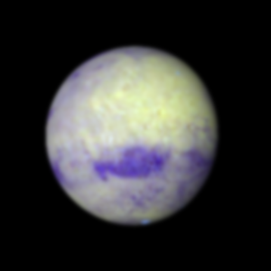

Get the *exact* right time for the WinJUPOS simulation. Blurring was 2.0 pixels I think.

|  |  |  |
| --- | --- | --- |
|  |  |  |
| 2018-06-26-0956_5-Mars-RGB-807-685-650-Wavelets-L(807).png | 2018-06-26-0956_5-Mars-RGB-807-685-650-Wavelets.png | 2018-06-26-0956_5-Mars-RGB-807-685-650-Wavelets-L(650).png |
|  |  |  |
| 2018-06-26-0945_0-Mars-RGB-Wavelets-WhtBal-Lum(R).png | 2018-06-26-0945_0-Mars-RGB-Wavelets-WhtBal.png | 2018-06-26-0945_0-Mars-RGB-Wavelets-WhtBal-Lum(B).png |
|  |  |  |
| 2018-06-26-0953_2-Mars-RGB-807-GRN-NUV-Wavelets-L(807).png | 2018-06-26-0953_2-Mars-RGB-807-GRN-NUV-Wavelets.png | 2018-06-26-0953_2-Mars-RGB-807-GRN-NUV-Wavelets-L(NUV).png |
|  |  |  |
| 2018-06-26-0947_9-Mars-RGB-GRN-BLU-NUV-Wavelets-L(GRN).png | 2018-06-26-0947_9-Mars-RGB-GRN-BLU-NUV-Wavelets.png | 2018-06-26-0947_9-Mars-RGB-GRN-BLU-NUV-Wavelets-L(NUV).png |

**Data Disposition:** Processed data reside on the Astronomy Thumb drive. Raw data have been zipped and located on the 2TB archive drive.

## July

### 2018-Jul-09 (Jul-10 UT): Venus, Jupiter and Saturn Video

Last Updated 7/10/2018

Transparency was very good 4/5, only because of some high haze. Seeing was also very good at 4/5. It was very hot in the day, about 100 F.

**Venus**

Venus was 16.8 arcsec in diameter.

|  |  |  |  |  |  |
| --- | --- | --- | --- | --- | --- |
| **Video File** | **Exposure** | **Gain** | **Gamma** | **Binning** | **Capture Area** |
| 2018-07-10-0143_3-Venus_380NUV.avi | 0.1 | 50 | 50 | 2 | 320x240 |
| 2018-07-10-0150_3-Venus_380NUV.avi | 0.1 | 50 | 50 | 2 | 320x240 |
| 2018-07-10-0154_2-Venus_380NUV.avi | 0.1 | 50 | 50 | 2 | 320x240 |
| 2018-07-10-0156_5-Venus_380NUV.avi | 0.1 | 50 | 50 | 2 | 320x240 |
| 2018-07-10-0158_6-Venus_380NUV.avi | 0.1 | 50 | 50 | 2 | 320x240 |
| 2018-07-10-0203_1-Venus_550GRN.avi | 0.0015 | 50 | 50 | 1 | 320x240 |
| 2018-07-10-0203_4-Venus_550GRN.avi | 0.0015 | 50 | 50 | 1 | 320x240 |
| 2018-07-10-0206_8-Venus_889CH4.avi | 0.044 | 50 | 50 | 2 | 320x240 |
| 2018-07-10-0209_0-Venus_889CH4.avi | 0.044 | 50 | 50 | 2 | 320x240 |

|  |  |  |
| --- | --- | --- |
|  |  |  |
| 2018-07-10-0200_6-Venus-RGB-Derot.jpg | 2018-07-10-0200_6-Venus-L(889)-Derot.jpg | 2018-07-10-0200_6-Venus-L(380)-Wavelets.jpg |

**Jupiter**

Jupiter was 40.1 arcsec in diameter. I got good captures of Ganymede in several (all?) filter bands. At least in 685NIR it looks like some albedo features are evident though perhaps only as an offset center of brightness. I once had a good reference on center of brightness offsets from the center of figure with relevance to Galilean Satellite mutual occultation timing. Go on Arxiv.org and search “mutual occultation.”

|  |  |  |  |  |  |
| --- | --- | --- | --- | --- | --- |
| **Video File** | **Exposure** | **Gain** | **Gamma** | **Binning** | **Capture Area** |
| 2018-07-10-0240_2-Jupiter_650RED.avi | 0.1 | 50 | 50 | 1 | 640x480 |
| 2018-07-10-0242_8-Jupiter_550GRN.avi | 0.07 | 50 | 50 | 1 | 640x480 |
| 2018-07-10-0245_4-Jupiter_450BLU.avi | 0.07 | 50 | 50 | 1 | 640x480 |
| 2018-07-10-0249_1-Jupiter_685NIR.avi | 0.1 | 50 | 50 | 1 | 640x480 |
| 2018-07-10-0252_0-Jupiter_807NIR.avi | 0.1 | 50 | 50 | 2 | 640x480 |
| 2018-07-10-0259_8-Jupiter_889CH4.avi | 0.999 | 100 | 50 | 2 | 640x480 |
| 2018-07-10-0309_8-Jupiter_380NUV.avi | 0.4 | 100 | 50 | 2 | 640x480 |

|  |  |  |  |  |  |
| --- | --- | --- | --- | --- | --- |
| **Video File** | **Exposure** | **Gain** | **Gamma** | **Binning** | **Capture Area** |
| 2018-07-10-0318_5-Dark_380NUV.avi | 0.4 | 100 | 50 | 2 | 640x480 |
| 2018-07-10-0320_3-Dark_889CH4.avi | 0.999 | 100 | 50 | 2 | 640x480 |

|  |  |
| --- | --- |
|  |  |
| 2018-07-10-0242_8-Hill-Jupiter-RGB-WhtBal-ColSmth-Wavelets.jpg | 2018-07-10-0247_1-Hill-Jupiter-807+685+RED-RGB-WhtBal-ClrSmth-Wavelets.jpg |
|  |  |
| 2018-07-10-0257_5-Hill-Jupiter-CH4-GRN-NUV-RGB-ClrSmth-Wavelets.jpg | 2018-07-10-0254_9-Hill-Jupiter-807-GRN-NUV-RGB-WhtBal-ClrSmth-Wavelets.jpg |

**Saturn**

Saturn was 18.3 arcsec in diameter. Polar hexagon is not visible, but there are hints of the Encke gap on the east ansa of the rings. There’s a faint detection of Tethys in the 685NIR image. Mimas and Enceladus would also be in the field of view, but don’t seem to have reached detectability.

|  |  |  |  |  |  |
| --- | --- | --- | --- | --- | --- |
| **Video File** | **Exposure** | **Gain** | **Gamma** | **Binning** | **Capture Area** |
| 2018-07-10-0350_0-Saturn_650RED.avi | 0.08 | 100 | 50 | 1 | 640x480 |
| 2018-07-10-0352_6-Saturn_550GRN.avi | 0.05 | 100 | 50 | 1 | 640x480 |
| 2018-07-10-0355_1-Saturn_450BLU.avi | 0.05 | 100 | 50 | 1 | 640x480 |
| 2018-07-10-0358_8-Saturn_685NIR.avi | 0.08 | 100 | 50 | 1 | 640x480 |
| 2018-07-10-0403_3-Saturn_807NIR.avi | 0.08 | 100 | 50 | 2 | 640x480 |
| 2018-07-10-0412_1-Saturn_685NIR.avi | 0.3 | 50 | 50 | 1 | 640x480 |

|  |  |  |  |  |  |
| --- | --- | --- | --- | --- | --- |
| **Video File** | **Exposure** | **Gain** | **Gamma** | **Binning** | **Capture Area** |
| 2018-07-10-0404_9-Dark_807NIR.avi | 0.08 | 100 | 50 | 2 | 640x480 |

|  |  |
| --- | --- |
|  |  |
| 2018-07-10-0352_6-Hill-Saturn-RGB-WhtBal-ClrSmth-Wavelets.jpg | 2018-07-10-0401_1-Saturn_RED+NIR-Wavelets.jpg |
|  |  |
| 2018-07-10-0356_3-Hill-Saturn-R(R+NIR)GB-RGB-ClrSmth-WhtBal-Wavelets.jpg |  |

**Data Disposition:** Processed data reside on the Astronomy Thumb drive. Raw data have been zipped and located on the 2TB archive drive.

### 2018-Jul-11 (Jul-12 UT): Jupiter and Jovian Moons

Last Updated 7/10/2018

The night started out very clear (4/5) and very steady (4/5). I imaged the moons of Jupiter early to see if I could resolve the disks, but decided to wait a two hours until the GRS transited. That way I could try to do winds over the same hemisphere as I imaged exactly two days (five Jovian rotations) ago. Unfortunately the weather did not cooperate. By the time I went out high clouds were moving in and I was only able to obtain images in 685, RED and GRN channels. On top of that the transparency was so low (<1/5) that I had to use 2x2 binning to get sufficient signal in some cases. In the end, the data quality was very low and the ability to compare features to the night of July 10 UT was very limited.

|  |  |
| --- | --- |
|  | 2018-07-12-0250_9-Io_685NIR-Stack800-Combined-2X-Wavelets4x3+5x3-NorthUp-Crop.jpg |
|  | 2018-07-12-0250_9-Europa_685NIR-Stack400-Wavelets1x20+2x5-2X-NorthUp-Crop.jpg |
|  | 2018-07-12-0309_0-Ganymede_685NIR-Stack1500-Combined-2X-Wavelets4x3+5x3-NorthUp-Crop.jpg |
|  | 2018-07-12-0259_2-Callisto_685NIR-Stack700-Combined-2X-Wavelets4x3+5x3-NorthUp-Crop.jpg |

|  |  |  |  |  |  |
| --- | --- | --- | --- | --- | --- |
| **Video File** | **Exposure** | **Gain** | **Gamma** | **Binning** | **Capture Area** |
| 2018-07-12-0248_4-Capture.avi | 0.05 | 100 | 50 | 1 | 320x240 |
| 2018-07-12-0250_9-Europa_685NIR.avi | 0.05 | 100 | 50 | 1 | 320x240 |
| 2018-07-12-0253_4-Io_685NIR.avi | 0.05 | 100 | 50 | 1 | 320x240 |
| 2018-07-12-0257_3-Callisto_685NIR.avi | 0.1 | 100 | 50 | 1 | 320x240 |
| 2018-07-12-0301_0-Callisto_685NIR.avi | 0.05 | 100 | 50 | 1 | 320x240 |
| 2018-07-12-0304_8-Ganymede_685NIR.avi | 0.1 | 100 | 50 | 1 | 320x240 |
| 2018-07-12-0307_0-Ganymede_685NIR.avi | 0.1 | 100 | 50 | 1 | 320x240 |
| 2018-07-12-0309_3-Ganymede_685NIR.avi | 0.1 | 100 | 50 | 1 | 320x240 |
| 2018-07-12-0311_6-Ganymede_685NIR.avi | 0.1 | 100 | 50 | 1 | 320x240 |
| 2018-07-12-0314_2-Ganymede_685NIR.avi | 0.1 | 100 | 50 | 1 | 320x240 |

|  |  |  |  |  |  |
| --- | --- | --- | --- | --- | --- |
| **Video File** | **Exposure** | **Gain** | **Gamma** | **Binning** | **Capture Area** |
| 2018-07-12-0302_8-Dark_685NIR_50ms.avi | 0.05 | 100 | 50 | 1 | 320x240 |
| 2018-07-12-0303_1-Dark_685NIR_100ms.avi | 0.1 | 100 | 50 | 1 | 320x240 |

Photometry

|  |  |  |  |  |  |  |
| --- | --- | --- | --- | --- | --- | --- |
| **Video File** | **Exposure** | **Gain** | **Binning** | **Frames** | **Signal** | **FWHM** |
| 2018-07-12-0248_4-Io_685NIR.avi | 0.05 | 100 | 1 | 400 | 2.63e6 | 8.58 |
| 2018-07-12-0253_4-Io_685NIR.avi | 0.05 | 100 | 1 | 400 | 2.79e6 | 7.91 |
|  |  |  |  | 800 | 5.42e7±1.6e6 | 8.25±0.34 |
| 2018-07-12-0250_9-Europa_685NIR.avi | 0.05 | 100 | 1 | 1 | 3.62e6 | 8.75 |
|  |  |  |  |  | 7.24e7 |  |
| 2018-07-12-0257_3-Callisto_685NIR.avi | 0.1 | 100 | 1 | 300 | 2.84e6 | 10.98 |
| 2018-07-12-0301_0-Callisto_685NIR.avi | 0.05 | 100 | 1 | 400 | 4.05e6 | 10.15 |
|  |  |  |  |  | 4.59e7±8.1e6 | 10.57±0.42 |
| 2018-07-12-0304_8-Ganymede_685NIR.avi | 0.1 | 100 | 1 | 300 | 7.13e6 | 8.94 |
| 2018-07-12-0307_0-Ganymede_685NIR.avi | 0.1 | 100 | 1 | 300 | 7.81e6 | 10.77 |
| 2018-07-12-0309_3-Ganymede_685NIR.avi | 0.1 | 100 | 1 | 300 | 7.88e6 | 11.32 |
| 2018-07-12-0311_6-Ganymede_685NIR.avi | 0.1 | 100 | 1 | 300 | 7.84e6 | 10.46 |
| 2018-07-12-0314_2-Ganymede_685NIR.avi | 0.1 | 100 | 1 | 300 | 7.56e6 | 11.18 |
|  |  |  |  | 1500 | 7.64e7±1.4e6 | 10.53±0.43 |

|  |
| --- |
|  |
| 2018-07-12-0411_4-Hill-Jupiter-685-650-550-RGB-WhtBal-ClrSmth-Wavelets4x5+5x5.png |

|  |  |  |  |  |  |
| --- | --- | --- | --- | --- | --- |
| **Video File** | **Exposure** | **Gain** | **Gamma** | **Binning** | **Capture Area** |
| 2018-07-12-0408_6-Jupiter_685NIR.avi | 0.15 | 50 | 50 | 1 | 640x480 |
| 2018-07-12-0410_2-Jupiter_650RED.avi | 0.15 | 50 | 50 | 1 | 640x480 |
| 2018-07-12-0411_8-Jupiter_650RED.avi | 0.15 | 50 | 50 | 2 | 640x480 |
| 2018-07-12-0414_6-Jupiter_550GRN.avi | 0.15 | 50 | 50 | 2 | 640x480 |

**Data Disposition:** Processed data reside on the Astronomy Thumb drive. Raw data have been zipped and located on the 2TB archive drive.

### 2018-Jul-14 (Jul-15 UT): Jupiter, Saturn, and Mars Video

Last Updated 7/10/2018

Transparency was very poor and variable due to high clouds. Seeing was very good at 4/5.

|  |  |  |  |  |  |
| --- | --- | --- | --- | --- | --- |
| **Video File** | **Exposure** | **Gain** | **Gamma** | **Binning** | **Capture Area** |
| 2018-07-15-0404_5-Jupiter_685NIR.avi | 0.132 | 50 | 50 | 1 | 640x480 |
| 2018-07-15-0407_1-Jupiter_650RED.avi | 0.132 | 50 | 50 | 1 | 640x480 |
| 2018-07-15-0409_8-Jupiter_807NIR.avi | 0.132 | 50 | 50 | 2 | 640x480 |
| 2018-07-15-0413_9-Jupiter_889CH4.avi | 0.999 | 100 | 50 | 2 | 640x480 |
| 2018-07-15-0418_2-Jupiter_550GRN.avi | 0.08 | 50 | 50 | 1 | 640x480 |
| 2018-07-15-0422_3-Jupiter_450BLU.avi | 0.1 | 50 | 50 | 1 | 640x480 |
| 2018-07-15-0429_1-Jupiter_380NUV.avi | 0.5 | 90 | 50 | 2 | 640x480 |

|  |  |  |  |  |  |
| --- | --- | --- | --- | --- | --- |
| **Video File** | **Exposure** | **Gain** | **Gamma** | **Binning** | **Capture Area** |
| 2018-07-15-0432_3-Dark_380NUV.avi | 0.5 | 90 | 50 | 2 | 640x480 |
| 2018-07-15-0439_1-Dark_889CH4.avi | 0.999 | 100 | 50 | 2 | 1280x960 |

|  |  |
| --- | --- |
|  |  |
| 2018-07-15-0415_9-Hill-Jupiter-RGB-WhtBal-ColSmth-Wavelets.jpg | 2018-07-15-0407_1-Hill-Jupiter-807-685-650-RGB-WhtBal-ColSmth-Sat130pct-Wavelets.jpg |
|  |  |
| 2018-07-15-0420_4-Hill-Jupiter-889-GRN-NUV-RGB-WhtBal-ColSmth-Wavelets.jpg | 2018-07-15-0419_0-Hill-Jupiter-807-GRN-NUV-RGB-WhtBal-ColSmth-Wavelets.jpg |

Rotation 13.68 deg, PA 18.33 deg, Decl -15 deg

|  |  |  |  |  |  |
| --- | --- | --- | --- | --- | --- |
| **Video File** | **Exposure** | **Gain** | **Gamma** | **Binning** | **Capture Area** |
| 2018-07-15-0443_6-Saturn_550GRN.avi | 0.1 | 100 | 50 | 1 | 640x480 |
| 2018-07-15-0446_1-Saturn_450BLU.avi | 0.15 | 100 | 50 | 1 | 640x480 |
| 2018-07-15-0450_1-Saturn_650RED.avi | 0.15 | 100 | 50 | 1 | 640x480 |
| 2018-07-15-0451_6-Saturn_650RED.avi | 0.12 | 100 | 50 | 1 | 640x480 |
| 2018-07-15-0453_2-Saturn_685NIR.avi | 0.12 | 100 | 50 | 1 | 640x480 |
| 2018-07-15-0456_1-Saturn_685NIR.avi | 0.08 | 100 | 50 | 1 | 640x480 |
| 2018-07-15-0500_2-Saturn_685NIR.avi | 0.08 | 100 | 50 | 1 | 640x480 |
| 2018-07-15-0503_0-Saturn_685NIR.avi | 0.08 | 100 | 50 | 1 | 640x480 |
| 2018-07-15-0510_5-Saturn_685NIR.avi | 0.999 | 100 | 50 | 2 | 1280x960 |
| 2018-07-15-0555_5-Saturn_650RED.avi | 0.1 | 100 | 50 | 1 | 640x480 |
| 2018-07-15-0557_9-Saturn_550GRN.avi | 0.06 | 100 | 50 | 1 | 640x480 |
| 2018-07-15-0600_4-Saturn_450BLU.avi | 0.1 | 100 | 50 | 1 | 640x480 |
| 2018-07-15-0604_7-Saturn_685NIR.avi | 0.07 | 100 | 50 | 1 | 640x480 |

|  |  |  |  |  |  |
| --- | --- | --- | --- | --- | --- |
| **Video File** | **Exposure** | **Gain** | **Gamma** | **Binning** | **Capture Area** |
| 2018-07-15-0514_1-LargeDark_685NIR.avi | 0.999 | 100 | 50 | 2 | 1280x960 |

|  |  |
| --- | --- |
|  |  |
| 2018-07-15-0518_8-Hill-Saturn-RGB-WhtBal-ClrSmth-Wavelets.jpg | 2018-07-15-0511_9-Saturn_RED+NIR-Combined-Wavelets.jpg |
|  |  |
| 2018-07-15-0518_6-Hill-Saturn-(685+RED)-GRN-BLU-RGB-WhtBal-ClrSmth-Wavelets.jpg | 2018-07-15-0510_5-Saturn_685NIR-Stack200-Gamma-HistWavelets-Crop-Annotated.jpg |

Rotation 4.02 deg, PA 5.75 deg, Decl -22 deg

**Mars**

It was difficult to orient the rotation angle of Mars due to the partial obscuration of the south polar cap by dust. I analyzed the position angles of Jupiter and Saturn along with my best fit plate rotations and determined that the necessary plate rotation angle for Mars was very near to zero. This was confirmed by comparison to online images of Mars at the same epoch.

|  |  |  |  |  |  |
| --- | --- | --- | --- | --- | --- |
| **Video File** | **Exposure** | **Gain** | **Gamma** | **Binning** | **Capture Area** |
| 2018-07-15-0531_3-Mars_685NIR.avi | 0.02 | 50 | 50 | 1 | 320x240 |
| 2018-07-15-0533_2-Mars_650RED.avi | 0.04 | 50 | 50 | 1 | 320x240 |
| 2018-07-15-0535_0-Mars_807NIR.avi | 0.02 | 50 | 50 | 2 | 320x240 |
| 2018-07-15-0537_0-Mars_889CH4.avi | 0.1 | 80 | 50 | 2 | 320x240 |
| 2018-07-15-0539_5-Mars_550GRN.avi | 0.1 | 50 | 50 | 2 | 640x480 |
| 2018-07-15-0541_2-Mars_450BLU.avi | 0.2 | 50 | 50 | 2 | 640x480 |

|  |  |  |  |
| --- | --- | --- | --- |
|  |  |  |  |
| 2018-07-15-0537_0-Mars_889CH4-Derotated.png | 2018-07-15-0535_0-Mars_807NIR-Derotated.png | 2018-07-15-0531_3-Mars_685NIR-Derotated.png | 2018-07-15-0533_2-Mars_650RED-Derotated.png |
|  |  |  |  |
| 2018-07-15-0533_2-Mars_807+685+650-Wavelets4x10.png | 2018-07-15-0539_5-Mars_550GRN-Derotated.png | 2018-07-15-0541_2-Mars_450BLU-Derotated.png |  |

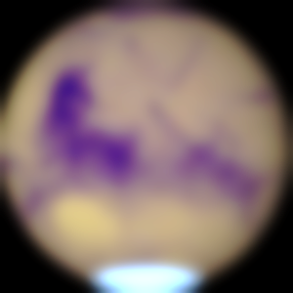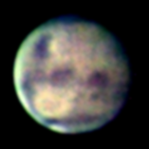

|  |  |  |
| --- | --- | --- |
|  |  |  |
| 2018-07-15-0533_2-Mars-807-685-650-RGB-Wavelets4x10-WhtBal-ColSmth-Sat150pct-L(R)RGB.png | 2018-07-15-0533_2-Mars-807-685-650-RGB-Wavelets4x10-WhtBal-ColSmth-Sat150pct.png | 2018-07-15-0533_2-Mars-807-685-650-RGB-Wavelets4x10-WhtBal-ColSmth-Sat150pct-L(B)RGB.png |
|  |  |  |
| 2018-07-15-0538_0-Mars-RGB-WhtBal-ClrSmth-Wavelets-L(R)RGB.png | 2018-07-15-0538_0-Mars-RGB-WhtBal-ClrSmth-Wavelets.png | 2018-07-15-0538_0-Mars-RGB-WhtBal-ClrSmth-Wavelets-L(B)RGB.png |
|  |  |  |
| 2018-07-15-0538_0-Mars-(807-685-RED)BG-RGB-WhtBal-Stuff-L(R)RGB.png | 2018-07-15-0538_0-Mars-(807-685-RED)BG-RGB-WhtBal-Stuff.png | 2018-07-15-0538_0-Mars-(807-685-RED)BG-RGB-WhtBal-Stuff-L(B)RGB.png |

**Data Disposition:** Processed data reside on the Astronomy Thumb drive. Raw data have been

zipped and located on the 2TB archive drive.

### 2018-Jul-17 (Jul-18 UT): Moon, Jupiter, and Saturn Video

Last Updated 7/10/2018

Transparency was good trending to poor (4->2) due to incoming haze. Seeing was good at 3/5.

|  |  |  |  |  |  |
| --- | --- | --- | --- | --- | --- |
| **Video File** | **Exposure** | **Gain** | **Gamma** | **Binning** | **Capture Area** |
| 2018-07-18-0147_1-Moon_685NIR.avi | 0.0126 | 50 | 50 | 2 | 640x480 |

I need to determine this location!

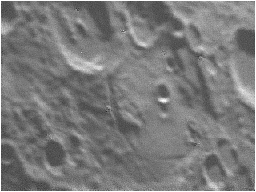

2018-07-18-0147_1-Moon_685NIR-Stack450-Wavelets1x50.png

|  |  |  |  |  |  |
| --- | --- | --- | --- | --- | --- |
| **Video File** | **Exposure** | **Gain** | **Gamma** | **Binning** | **Capture Area** |
| 2018-07-18-0314_4-Jupiter_685NIR.avi | 0.121109 | 50 | 50 | 1 | 640x480 |
| 2018-07-18-0317_0-Jupiter_650RED.avi | 0.121109 | 50 | 50 | 1 | 640x480 |
| 2018-07-18-0319_8-Jupiter_807NIR.avi | 0.121 | 50 | 50 | 2 | 640x480 |
| 2018-07-18-0323_3-Jupiter_550GRN.avi | 0.082204 | 50 | 50 | 1 | 640x480 |
| 2018-07-18-0325_8-Jupiter_450BLU.avi | 0.102525 | 50 | 50 | 1 | 640x480 |
| 2018-07-18-0331_3-Jupiter_380NUV.avi | 0.5 | 100 | 50 | 2 | 640x480 |
| 2018-07-18-0339_3-Jupiter_889CH4.avi | 0.999 | 100 | 50 | 2 | 640x480 |

|  |  |  |  |  |  |
| --- | --- | --- | --- | --- | --- |
| **Video File** | **Exposure** | **Gain** | **Gamma** | **Binning** | **Capture Area** |
| 2018-07-18-0334_4-Dark_380NUV.avi | 0.5 | 100 | 50 | 2 | 640x480 |
| 2018-07-18-0342_4-Dark_889CH4.avi | 0.999 | 100 | 50 | 2 | 640x480 |

|  |  |
| --- | --- |
|  |  |
| 2018-07-18-0322_0-Hill-Jupiter-RGB-WhtBal-ColSmth-Wavelets.png | 2018-07-18-0317_1-Hill-Jupiter-807-685-650-RGB-WhtBal-ClrSmth-Sat130pct-Wavelets.png |
|  |  |
| 2018-07-18-0331_3-Hill-Jupiter-889-550-380-RGB-WhtBal-ClrSmth-Wavelets.png | 2018-07-18-0324_8-Hill-Jupiter-807-550-380-RGB-WhtBal-ClrSmth-Wavelets.png |

|  |  |  |  |  |  |
| --- | --- | --- | --- | --- | --- |
| **Video File** | **Exposure** | **Gain** | **Gamma** | **Binning** | **Capture Area** |
| 2018-07-18-0351_4-Saturn_685NIR.avi | 0.083228 | 90 | 50 | 1 | 640x480 |
| 2018-07-18-0356_5-Saturn_685NIR_Large.avi | 0.5 | 100 | 98 | 2 | 1280x960 |
| 2018-07-18-0406_5-Saturn_685NIR.avi | 0.5 | 50 | 50 | 1 | 640x480 |
| 2018-07-18-0411_3-Saturn_685NIR.avi | 0.03 | 100 | 50 | 2 | 640x480 |

|  |  |  |  |  |  |  |
| --- | --- | --- | --- | --- | --- | --- |
| **Video File** | **Exposure** | | **Gain** | **Gamma** | **Binning** | **Capture Area** |
| 2018-07-18-0358_4-Dark_685NIR_Large.avi | 0.5 | | 100 | 98 | 2 | 1280x960 |
| 2018-07-18-0413_0-Dark_685NIR.avi | 0.03 | | 100 | 50 | 2 | 640x480 |
|  | |  | | | | |
| 2018-07-18-0351_4-Saturn_685NIR-Derotated.png | | 2018-07-18-0403_1-Saturn_685NIR-Combined-Wavelets.png | | | | |
|  | |  | | | | |
| 2018-07-18-0406_5-Saturn_685NIR-Derotated.png | | 2018-07-18-0411_3-Saturn_685NIR-Derotated.png | | | | |
|  | |  | | | | |
| 2018-07-18-0356_5-Saturn_685NIR_Large-Stack150-Wavelets3x5+4x5-2X-StrRot-Annotated-Crop.png | | 2018-07-18-0356_5-Saturn_685NIR_Large-Stack150-Wavelets3x5+4x5-2X-StrRot-RotGrad-Annotated-Crop.png | | | | |

**Data Disposition:** Processed data reside on the Astronomy Thumb drive. Raw data have been zipped and put on the 2TB archive drive.

### 2018-Jul-30 (Jul-31 UT): Venus, Saturn, and Mars Video

Last Updated 7/10/2018

Transparency was very good at 4/5 and seeing was much better than predicted 4/5 or better.

Venus images were taken rather late, just before it tucked itself behind a tree. I took two videos. The first was with the NUV filter. Oddly, it was at a gain of 41 with and exposure of 100ms. Then I took another video. It’s unclear what filter it was with, but it was labeled NUV. It also used a gain of 41, but an exposure of 150ms. The reason I question that it was NUV, is because it is saturated at times as it peaks out between leaves as it is setting. I don’t think that would be the case with NUV. Venus was 20.2 arcsec in diameter.

|  |  |  |  |  |  |
| --- | --- | --- | --- | --- | --- |
| **Video File** | **Exposure** | **Gain** | **Gamma** | **Binning** | **Capture Area** |
| 2018-07-31-0236_9-Venus_380NUV.avi | 0.15 | 41 | 50 | 2 | 320x240 |
| 2018-07-31-0241_0-Venus_380NUV.avi | 0.1 | 41 | 50 | 2 | 320x240 |

|  |
| --- |
|  |
| 2018-07-31-0236_9-Venus_380NUV-Derotated.png |

**Saturn**

Need to stack un navigated images to see what moons are evident.

|  |  |
| --- | --- |
|  |  |
| 2018-07-31-0511_3-Hill-Saturn-RGB-WhtBal-ColSmth-Wavelets.png | 2018-07-31-0513_7-Hill-Saturn-685-GRN-BLU-RGB-WhtBal-ClrSmth-Wavelets.png |
|  |  |
| 2018-07-31-0513_0-Saturn_AllBands-Moons-Annotated-Cropped.png | 2018-07-31-0513_0-Saturn_AllBands-Moons-RotGrad-Annotated-Cropped.png |

I seem to have detected a prominent storm in far north. I think there is more than one storm ongoing and it would be good to confirm with other reports and images from other observers.

|  |  |  |  |  |  |
| --- | --- | --- | --- | --- | --- |
| **Video File** | **Exposure** | **Gain** | **Gamma** | **Binning** | **Capture Area** |
| 2018-07-31-0502_1-Saturn_650RED.avi | 0.07 | 100 | 50 | 1 | 640x480 |
| 2018-07-31-0504_6-Saturn_550GRN.avi | 0.05 | 100 | 50 | 1 | 640x480 |
| 2018-07-31-0507_4-Saturn_685NIR.avi | 0.05 | 100 | 50 | 1 | 640x480 |
| 2018-07-31-0511_1-Saturn_450BLU.avi | 0.05 | 100 | 50 | 1 | 640x480 |
| 2018-07-31-0513_2-Saturn_450BLU.avi | 0.05 | 100 | 50 | 1 | 640x480 |
| 2018-07-31-0516_7-Saturn_550GRN.avi | 0.05 | 100 | 50 | 1 | 640x480 |
| 2018-07-31-0520_3-Saturn_650RED.avi | 0.07 | 100 | 50 | 1 | 640x480 |
| 2018-07-31-0522_8-Saturn_685NIR.avi | 0.05 | 100 | 50 | 1 | 640x480 |
| 2018-07-31-0524_9-Saturn_685NIR.avi | 0.05 | 100 | 50 | 1 | 640x480 |

**Mars**

|  |  |  |  |
| --- | --- | --- | --- |
|  |  |  |  |
| 2018-07-31-0607_4-Mars_889CH4-Derotated.png | 2018-07-31-0601_6-Mars_807NIR-Combined.png | 2018-07-31-0548_1-Mars-685NIR-Derotated.png | 2018-07-31-0550_4-Mars_650RED-Derotated.png |
|  |  |  |  |
| 2018-07-31-0553_4-Mars_807+685+650-Wavelets.png | 2018-07-31-0552_7-Mars_550GRN-Derotated.png | 2018-07-31-0555_3-Mars_450BLU-Derotated.png |  |

|  |  |  |
| --- | --- | --- |
|  |  |  |
| 2018-07-31-0553_4-Mars-807-685-650-RGB-WhtBal-ClrSmth-Wavelets-L(R)RGB.png | 2018-07-31-0553_4-Mars-807-685-650-RGB-WhtBal-ClrSmth-Wavelets.png | 2018-07-31-0553_4-Mars-807-685-650-RGB-WhtBal-ClrSmth-Wavelets-L(B)RGB.png |
|  |  |  |
| 2018-07-31-0552_8-Mars-RGB-WhtBal-ClrSmth-Wavelets-L(R)RGB.png | 2018-07-31-0552_8-Mars-RGB-WhtBal-ClrSmth-Wavelets.png | 2018-07-31-0552_8-Mars-RGB-WhtBal-ClrSmth-Wavelets-L(B)RGB.png |
|  |  |  |
| 2018-07-31-0553_8-Mars-(807+685+650)GB-RGB-WhtBal-ClrSmth-Wavelets-L(R)RGB.png | 2018-07-31-0553_8-Mars-(807+685+650)GB-RGB-WhtBal-ClrSmth-Wavelets.png | 2018-07-31-0553_8-Mars-(807+685+650)GB-RGB-WhtBal-ClrSmth-Wavelets-L(B)RGB.png |

|  |  |  |  |  |  |
| --- | --- | --- | --- | --- | --- |
| **Video File** | **Exposure** | **Gain** | **Gamma** | **Binning** | **Capture Area** |
| 2018-07-31-0548_1-Mars_685NIR.avi | 0.02 | 50 | 50 | 1 | 640x480 |
| 2018-07-31-0550_4-Mars_650RED.avi | 0.03 | 50 | 50 | 1 | 640x480 |
| 2018-07-31-0552_7-Mars_550GRN.avi | 0.03 | 50 | 50 | 1 | 640x480 |
| 2018-07-31-0555_3-Mars_450BLU.avi | 0.05 | 50 | 50 | 1 | 640x480 |
| 2018-07-31-0559_6-Mars_807NIR.avi | 0.06 | 50 | 50 | 1 | 640x480 |
| 2018-07-31-0603_7-Mars_807NIR.avi | 0.06 | 50 | 50 | 1 | 640x480 |
| 2018-07-31-0607_4-Mars_889CH4.avi | 0.1 | 70 | 50 | 2 | 640x480 |

**Data Disposition:** Processed data reside on the Astronomy Thumb drive. Raw data have been zipped and put on the 2TB archive drive.

## August

### 2018-Jul-31 (Aug-01 UT): Jupiter Video

Last Updated 7/10/2018

A bit hazy, possibly from wildfire smoke, gave a moderate transparency of 3/5.

|  |  |
| --- | --- |
|  |  |
| 2018-08-01-0335_8-Hill-Jupiter-RGB-WhtBal-ClrSmth-Wavelets.jpg | 2018-08-01-0346_3-Hill-Jupiter-807-685-650-RGB-WhtBal-ClrSmth-Sat150pct-Wavelets.jpg |
|  |  |
| 2018-08-01-0346_5-Hill-Jupiter-889-550-380-RGB-WhtBal-ClrSmth-Wavelets.jpg | 2018-08-01-0345_4-Hill-Jupiter-807-GRN-NUV-RGB-WhtBal-ClrSmth-Waveletes.jpg |

I have measured many features on these images, but there may be more measurements required. Around Oval BA it appears we may see S2 oval A8, but there is also an adjacent similar feature. Also, there are a number of dark spots along the southern edge of the NEB that are prominent, but don’t really look like classical projections. Finally, there are a number of dark spots or projections on the southern edge of the SEB that I’m not sure how to record. Some of them sort of form sectors. I need to read up on interpretations from BAA/BAS latest Jupiter reports.

|  |  |  |  |  |  |
| --- | --- | --- | --- | --- | --- |
| **Video File** | **Exposure** | **Gain** | **Gamma** | **Binning** | **Capture Area** |
| 2018-08-01-0332_3-Jupiter_650RED.avi | 0.05 | 80 | 50 | 1 | 640x480 |
| 2018-08-01-0335_8-Jupiter_550GRN.avi | 0.03 | 80 | 50 | 1 | 640x480 |
| 2018-08-01-0339_2-Jupiter_450BLU.avi | 0.04 | 80 | 50 | 1 | 640x480 |
| 2018-08-01-0345_5-Jupiter_380NUV.avi | 0.5 | 100 | 50 | 2 | 640x480 |
| 2018-08-01-0351_7-Jupiter_685NIR.avi | 0.035106 | 80 | 50 | 1 | 640x480 |
| 2018-08-01-0355_0-Jupiter_807NIR.avi | 0.05 | 80 | 50 | 2 | 640x480 |
| 2018-08-01-0358_2-Jupiter_889CH4.avi | 0.999 | 100 | 50 | 2 | 640x480 |

|  |  |  |  |  |  |
| --- | --- | --- | --- | --- | --- |
| **Video File** | **Exposure** | **Gain** | **Gamma** | **Binning** | **Capture Area** |
| 2018-08-01-0348_4-Dark_380NUV.avi | 0.5 | 100 | 50 | 2 | 640x480 |
| 2018-08-01-0400_9-Dark_889CH4.avi | 0.999 | 100 | 50 | 2 | 640x480 |

**Data Disposition:** Processed data reside on the Astronomy Thumb drive. Raw data have been zipped and put on the 2TB archive drive.

### 2018-Aug-12 (Aug-13 UT): Venus, Jupiter, and Saturn Video

Last Updated 7/10/2018

VERY hazy from California wild fires. I estimate transparency at 2/5 at best. Seeing was quite good at 4/5. Strong skunk smell made me call it a night before imaging Mars.

|  |  |  |  |  |  |
| --- | --- | --- | --- | --- | --- |
| **Video File** | **Exposure** | **Gain** | **Gamma** | **Binning** | **Capture Area** |
| 2018-08-13-0149_7-Venus_380NUV.avi | 0.1 | 75 | 50 | 2 | 640x480 |
| 2018-08-13-0151_8-Venus_380NUV.avi | 0.1 | 75 | 50 | 2 | 640x480 |
| 2018-08-13-0153_8-Venus_380NUV.avi | 0.1 | 75 | 50 | 2 | 640x480 |
| 2018-08-13-0156_7-Venus_889CH4.avi | 0.025 | 75 | 50 | 2 | 640x480 |
| 2018-08-13-0157_3-Venus_889CH4.avi | 0.025 | 75 | 50 | 2 | 640x480 |
| 2018-08-13-0158_5-Venus_550GRN.avi | 0.001 | 50 | 50 | 2 | 320x240 |

|  |  |  |
| --- | --- | --- |
|  |  |  |
| 2018-08-13-0153_6-Venus_L(CH4)RGB-Derotated.png | 2018-08-13-0153_6-Venus_RGB-Derotated.png | 2018-08-13-0153_6-Venus_L(NUV)RGB-Derotated.png |

|  |  |  |  |  |  |
| --- | --- | --- | --- | --- | --- |
| **Video File** | **Exposure** | **Gain** | **Gamma** | **Binning** | **Capture Area** |
| 2018-08-13-0212_0-Jupiter_550GRN.avi | 0.1 | 50 | 50 | 1 | 640x480 |
| 2018-08-13-0214_2-Jupiter_450BLU.avi | 0.1 | 50 | 50 | 1 | 640x480 |
| 2018-08-13-0216_5-Jupiter_650RED.avi | 0.1 | 50 | 50 | 1 | 640x480 |
| 2018-08-13-0220_0-Jupiter_685NIR.avi | 0.1 | 50 | 50 | 1 | 640x480 |

|  |  |
| --- | --- |
|  |  |
| 2018-08-13-0214_2-Hill-Jupiter-RGB-ColBal-WhtBal-Wavelets3x10.png | 2018-08-13-0215_4-Hill-Jupiter-(685-GRN-BLU)-RGB-ColSmth-WhtBal-Wavelets3x10.png |

|  |  |  |  |  |  |
| --- | --- | --- | --- | --- | --- |
| **Video File** | **Exposure** | **Gain** | **Gamma** | **Binning** | **Capture Area** |
| 2018-08-13-0330_3-Saturn_685NIR.avi | 0.075 | 100 | 50 | 1 | 640x480 |
| 2018-08-13-0332_7-Saturn_60RED.avi | 0.075 | 100 | 50 | 1 | 640x480 |
| 2018-08-13-0336_2-Saturn_60RED.avi | 0.075 | 100 | 50 | 1 | 640x480 |
| 2018-08-13-0339_9-Saturn_450BLU.avi | 0.1 | 100 | 50 | 1 | 640x480 |
| 2018-08-13-0342_1-Saturn_450BLU.avi | 0.1 | 100 | 50 | 1 | 640x480 |
| 2018-08-13-0346_1-Saturn_550GRN.avi | 0.075 | 100 | 50 | 1 | 640x480 |
| 2018-08-13-0351_9-Saturn_650RED.avi | 0.1 | 100 | 50 | 1 | 640x480 |

|  |  |
| --- | --- |
|  |  |
| 2018-08-13-0341_5-Hill-Saturn-RGB-ClrSmth-WhtBal-Wavelets2x3+3x5.png | 2018-08-13-0337_5-Hill-Saturn-R(685)GB-RGB-ClrSmth-WhtBal-Wavelets2x3+3x5.png |
|  |  |
| 2018-08-13-0340_2-Hill-Saturn-R(685+R)GB-RGB-ClrSmth-WhtBal-Wavelets2x3+3x5.png | 2018-08-13-0341_0-Saturn_AllBands-Smth-Strtch-RotCrop-Annotated.png |

**Data Disposition:** Processed data reside on the Astronomy Thumb drive. Raw data have been zipped and put on the 2TB archive drive.

### 2018-Aug-13 (Aug-14 UT): Mars Video

Last Updated 7/10/2018

VERY hazy from California wild fires. I estimate transparency at 2/5 at best with additional high cirrus moving in. Seeing was quite good at 4/5.

|  |  |  |  |
| --- | --- | --- | --- |
|  |  |  |  |
| 2018-08-14-0326_4-Mars_889CH4.png | 2018-08-14-0322_9-Mars_807NIR-Wavelets4x5-Cont90pct.png | 2018-08-14-0332_2-Mars_685NIR-Wavelets3x5.png | 2018-08-14-0316_2-Mars_550RED.png |
|  |  |  |  |
| 2018-08-14-0323_8-Mars_807+685+RED-Wavelets3x5+4x5.png | 2018-08-14-0329_3-Mars_550GRN.png | 2018-08-14-0332_6-Mars_450BLU.png |  |

|  |  |  |
| --- | --- | --- |
|  |  |  |
| 2018-08-14-0323_8-Mars-(807-685-650)-RGB-ColSmth-WhtBal-Wavelets3x5+4x5-L(R)RGB.png | 2018-08-14-0323_8-Mars-(807-685-650)-RGB-ColSmth-WhtBal-Wavelets3x5+4x5.png | 2018-08-14-0323_8-Mars-(807-685-650)-RGB-ColSmth-WhtBal-Wavelets3x5+4x5-L(B)RGB.png |
|  |  |  |
| 2018-08-14-0326_0-Mars-RGB-ClrSmth-WhtBal-Wavelets4x5-L(R)RGB.png | 2018-08-14-0326_0-Mars-RGB-ClrSmth-WhtBal-Wavelets4x5.png | 2018-08-14-0326_0-Mars-RGB-ClrSmth-WhtBal-Wavelets4x5-L(B)RGB.png |
|  |  |  |
| 2018-08-14-0328_6-Mars-(807+685+650)GB-RGB-ClrSmth-WhtBal-Wavelets3x3+4x5-L(R)RGB.png | 2018-08-14-0328_6-Mars-(807+685+650)GB-RGB-ClrSmth-WhtBal-Wavelets3x3+4x5.png | 2018-08-14-0328_6-Mars-(807+685+650)GB-RGB-ClrSmth-WhtBal-Wavelets3x3+4x5-L(B)RGB.png |

**Data Disposition:** Processed data reside on the Astronomy Thumb drive. Raw data have been zipped and put on the 2TB archive drive.

## September

### 2018-Sep-12 (Sep-13 UT): Saturn and Vega Spectrum, Mars Video

Last Updated 9/13/2018

Average to good seeing (3/5) and excellent transparency 4/5-5/5.

**SATURN and VEGA**

|  |  |
| --- | --- |
|  | Saturn+Titan-Spectrum-20180913UT-550OPN-ALL-MedFilt-Crop.jpg |
|  | Saturn+Titan-Spectrum-20180913UT-550OPN-ALL-MedFilt-Crop-Str.jpg |
|  | VegaSpectrum-20180913UT-0001thur0012-550OPN-Rot-Crop-Log.jpg |

Vega was very close to the zenith giving an air mass of 1.0. The spectral images were processed using *SpectralProcessingScript.py* and *SpectrumFromFITS.py*. These use the old *SPLibrary.py*. Note the clear second order Balmer lines HI ζ at 777 nm. It would be pretty easy to determine the signal level of the second order if I had first order data at longer wavelengths. I do have such data in many other spectra, but have never actually compared the relative throughput for each order.

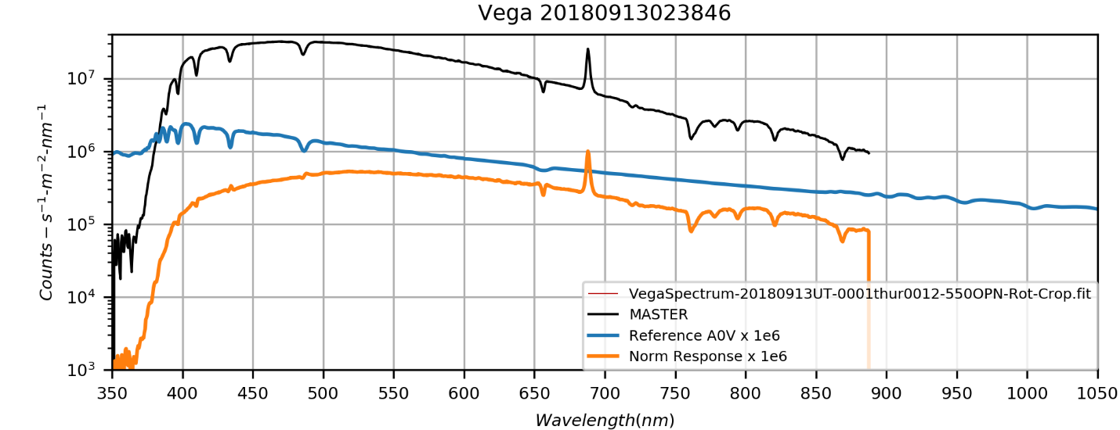

Vega_20180913023846_1D.png

Two spectra of Saturn were taken at different focuses. The plot below shows the mean of the two. The spectra were processed using SaturnSpectrum20180913UT.py, which was written to use *SpectrumFromFITS1.py* in the new *Spectroscopy* repository. This code is my new object-oriented spectral processing code and this Saturn spectra work is serving as a development pilot.

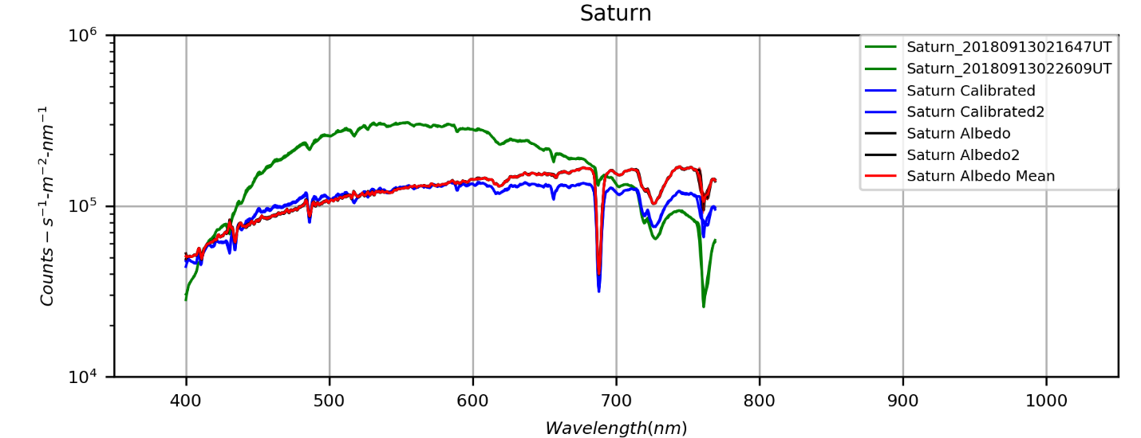

Saturn’s elevation was only 27 degrees, which gives an air mass of about 2.2. This is why the O2A band at 761 nm is so under corrected by the reference spectrum from Vega. This should also affect the weaker O2B band at 687 nm and the much weaker O2a band at 628 nm. The band at 687 nm is not of interest and is corrupted by a star present in the Vega calibration spectrum anyway. The 628 nm band is very close to the important CH4 band at 619 nm and so has the potential to depress the continuum longward of the CH4 band. This could result in under reporting of the 619 nm band equivalent width. Many solar and telluric lines are identifiable in the calibrated Saturn spectrum.

**Data Disposition: Vega, Saturn, and Titan spectral** raw data are zipped on Astronomy Laptop and ready for archive on 2TB drive. Processed data is in appropriate project directories on the Astronomy thumb drive.

**MARS**

|  |  |  |  |  |  |
| --- | --- | --- | --- | --- | --- |
| **Video File** | **Exposure** | **Gain** | **Gamma** | **Binning** | **Capture Area** |
| 2018-09-13-0336_0-Mars_550GRN.avi | 0.03 | 50 | 50 | 1 | 640x480 |
| 2018-09-13-0338_5-Mars_650RED.avi | 0.03 | 50 | 50 | 1 | 640x480 |
| 2018-09-13-0342_6-Mars_685NIR.avi | 0.025 | 50 | 50 | 1 | 640x480 |
| 2018-09-13-0344_4-Mars_807NIR.avi | 0.025 | 50 | 50 | 2 | 640x480 |
| 2018-09-13-0345_5-Mars_807NIR.avi | 0.025 | 50 | 50 | 2 | 640x480 |
| 2018-09-13-0347_6-Mars_889CH4.avi | 0.1 | 80 | 50 | 2 | 640x480 |
| 2018-09-13-0349_3-Mars_685NIR.avi | 0.005 | 50 | 50 | 2 | 320x240 |
| 2018-09-13-0349_6-Mars_685NIR.avi | 0.005 | 50 | 50 | 2 | 320x240 |
| 2018-09-13-0349_8-Mars_685NIR.avi | 0.005 | 50 | 50 | 2 | 320x240 |
| 2018-09-13-0350_1-Mars_685NIR.avi | 0.005 | 50 | 50 | 2 | 320x240 |
| 2018-09-13-0350_4-Mars_685NIR.avi | 0.005 | 50 | 50 | 2 | 320x240 |
| 2018-09-13-0351_2-Mars_650RED.avi | 0.007 | 50 | 50 | 2 | 320x240 |
| 2018-09-13-0351_5-Mars_650RED.avi | 0.007 | 50 | 50 | 2 | 320x240 |
| 2018-09-13-0351_7-Mars_650RED.avi | 0.007 | 50 | 50 | 2 | 320x240 |
| 2018-09-13-0352_0-Mars_650RED.avi | 0.007 | 50 | 50 | 2 | 320x240 |
| 2018-09-13-0353_0-Mars_550GRN.avi | 0.007 | 50 | 50 | 2 | 320x240 |
| 2018-09-13-0353_3-Mars_550GRN.avi | 0.007 | 50 | 50 | 2 | 320x240 |
| 2018-09-13-0353_5-Mars_550GRN.avi | 0.007 | 50 | 50 | 2 | 320x240 |
| 2018-09-13-0353_7-Mars_550GRN.avi | 0.007 | 50 | 50 | 2 | 320x240 |
| 2018-09-13-0357_5-Mars_450BLU.avi | 0.015 | 50 | 50 | 2 | 320x240 |
| 2018-09-13-0358_1-Mars_450BLU.avi | 0.015 | 50 | 50 | 2 | 320x240 |
| 2018-09-13-0403_0-Mars_380NUV.avi | 0.2 | 50 | 100 | 2 | 640x480 |
| 2018-09-13-0404_6-Mars_380NUV_Dark.avi | 0.2 | 50 | 100 | 2 | 640x480 |
| 2018-09-13-0405_2-Mars_889CH4_Dark.avi | 0.1 | 50 | 80 | 2 | 640x480 |

|  |  |  |  |
| --- | --- | --- | --- |
|  |  |  |  |
| 2018-09-13-0347_6-Mars_889CH4-Derotated.png | 2018-09-13-0344_9-Mars_807NIR-Derotated.png | 2018-09-13-0346_2-Mars_685NIR-Derotated.png | 2018-09-13-0345_0-Mars_650RED-Derotated.png |
|  |  |  |  |
| 2018-09-13-0347_2-Mars_All_Best-RED+NIR-Wavelets1x5+2x10+3x5+Cont70pct.png | 2018-09-13-0344_7-Mars_550GRN-Derotated.png | 2018-09-13-0357_8-Mars_450BLU-Derotated.png | 2018-09-13-0403_0-Mars_380NUV-Derotated.png |

|  |  |  |
| --- | --- | --- |
|  |  |  |
| 2018-09-13-0345_4-Mars-(807-685-650)-RGB-ClrSmth-WhtBal-Wavelets-L(807)RGB.png | 2018-09-13-0345_4-Mars-(807-685-650)-RGB-ClrSmth-WhtBal-Wavelets.png | 2018-09-13-0345_4-Mars-(807-685-650)-RGB-ClrSmth-WhtBal-Wavelets-L(650)RGB.png |
|  |  |  |
| 2018-09-13-0354_3-Mars-RGB-ClrSmth-WhtBal-Wavelets-L(R)RGB.png | 2018-09-13-0354_3-Mars-RGB-ClrSmth-WhtBal-Wavelets.png | 2018-09-13-0354_3-Mars-RGB-ClrSmth-WhtBal-Wavelets-L(B)RGB.png |
|  |  |  |
| 2018-09-13-0349_9-Mars-(BestNIR-GRN-BLU)-RGB-ClrSmth-WhtBal-L(NIR)RGB.png | 2018-09-13-0349_9-Mars-(BestNIR-GRN-BLU)-RGB-ClrSmth-WhtBal.png | 2018-09-13-0349_9-Mars-(BestNIR-GRN-BLU)-RGB-ClrSmth-WhtBal-L(BLU)RGB.png |

**Data Disposition:** **Mars** raw data have been zipped and put on the 2TB archive drive.

Processed data reside on the Astronomy Thumb drive.

### Autumn 2018 Planning

Last Updated 3/6/2018

* Observations: Dark around 7:30pm on Oct 15.
  + Spectra – 135mm
    - Mars – spectra (135mm) 13.7 arcsec on 10/15
    - Beta Lyrae – 200 lpm, 135mm, see if we can see shape changes in HAL profile or other lines…
  + Nebulae - 1260mm (possibly binned 2x2 with the ASI120MM)
    - M57 Ring Nebula – 486HIB, 742NIR, 807NIR, more 673SII, more 380NUV
  + Planet Video
    - Mars – Extended close out of the apparition – Transit 8:27 (Oct 15)
    - Neptune – Limit to 450BLU, 550GRN, 650RED, and 685NIR – Transit 10:25 (Oct 15) – Maybe try 2x2 binning to increase signal?
    - Uranus – Limit to 450BLU, 550GRN, 650RED, and 685NIR – Transit 1:21am (Oct 15) Very late! – Maybe try 2x2 binning to increase signal?
  + Planetary Nebula Video
    - NGC6543 Cat’s Eye Nebula – **550CLR**, 450BLU, 550GRN, 650GRN – Transit 5:21pm (Oct 15), but above 35 deg until 11:12 – Last imaged in 2011
    - NGC7009 Saturn Nebula – **650RED** (additional), **656HIA**, **501OIII**, 380NUV, 685NIR. – Transit 8:27 (Oct 15)
    - NGC7662 – Blue Small Nebula – 550CLR, 450BLU, 550GRN, 650RED – Transit 10:49 (Oct 15) – last imaged 2006!
  + Globular Cluster Video
    - M13 685NIR
    - M2 550CLR and/or 685NIR
  + Double Star Video
    - Hercules: Alpha, **Zeta**~~, 99~~
    - Lyra: **Eta**, **BU648**
    - Ophiuchus: Eta, Lambda, Tau, 36, 70, STF2173
    - Cygnus: Lambda, **61,** Mu, Delta, **STF2576 (new and faint, 8mV)**
    - Corona Borealis: Maybe too late in the season…but there are some good doubles
    - Draco – Mu, 20, 26, STF2398 (new and faint, 10mV – very close to Earth pair of red dwarfs)
    - Serpens: Delta
* Analysis
  + Update Mars report to modern format
  + Update Jupiter analysis and report including: better analysis coverage over apparitions, Python code for GRS size analysis, white oval analysis, and meridional wind analysis.
  + Update Saturn analysis and report.
  + M31 Multispectral Analysis *ala* M33, M81, M101 etc.
  + M81 reanalysis with 501OIII data
  + Solar Eclipse Movies, ratio analysis, etc.
  + Questions for OPT:
    - GoTo Mounts
    - Custom Filters

### 2018-Sep-22 (Sep-23 UT): Saturn, Double Star, and Mars Videos

Last Updated 9/13/2018

Excellent seeing (5/5) and very good transparency 4/5.

**SATURN**

|  |  |  |  |  |  |
| --- | --- | --- | --- | --- | --- |
| **Video File** | **Exposure** | **Gain** | **Gamma** | **Binning** | **Capture Area** |
| 2018-09-23-0315_2-Saturn_685NIR.avi | 0.05 | 100 | 50 | 1 | 640x480 |
| 2018-09-23-0316_9-Saturn_Dark_685NIR.avi | 0.05 | 100 | 50 | 1 | 640x480 |

|  |  |
| --- | --- |
|  |  |
| 2018-09-23-0315_2-Saturn_685NIR.png | 2018-09-23-0315_2-Saturn_685NIR-Stack600-Wavelets2x15+3x10+4x5-SmthStretch-Rot-Annotated.png |
|  |  |

TBD

**DOUBLE STARS**

|  |  |  |  |  |  |
| --- | --- | --- | --- | --- | --- |
| **Video File** | **Exposure** | **Gain** | **Gamma** | **Binning** | **Capture Area** |
| 2018-09-23-0229_0-EPS_LYR_A.avi | 0.07 | 100 | 50 | 1 | 640x480 |
| 2018-09-23-0231_9-EPS_LYR_B.avi | 0.07 | 100 | 50 | 1 | 640x480 |
| 2018-09-23-0233_7-Dark_685NIR.avi | 0.07 | 100 | 50 | 1 | 640x480 |
| 2018-09-23-0235_4-Drift_685NIR.avi | 0.07 | 100 | 50 | 1 | 1280x960 |
| 2018-09-23-0300_5-BU648_685NIR.avi | 0.07 | 100 | 50 | 1 | 640x480 |
| 2018-09-23-0301_9-BU648_685NIR.avi | 0.07 | 100 | 50 | 1 | 640x480 |
| 2018-09-23-0303_3-BU648_685NIR.avi | 0.07 | 100 | 50 | 1 | 640x480 |
| 2018-09-23-0307_5-ZetHer_685NIR.avi | 0.05 | 50 | 50 | 1 | 640x480 |
| 2018-09-23-0309_0-ZetHer_685NIR.avi | 0.05 | 50 | 50 | 1 | 640x480 |
| 2018-09-23-0352_8-MuCyg_685NIR.avi | 0.05 | 70 | 71 | 1 | 640x480 |
| 2018-09-23-0354_6-MuCyg_685NIR_Drift.avi | 0.05 | 100 | 71 | 1 | 1280x960 |
| 2018-09-23-0400_8-LamCyg_685NIR.avi | 0.07 | 70 | 71 | 1 | 640x480 |
| 2018-09-23-0406_9-DelCyg_685NIR.avi | 0.05 | 70 | 71 | 1 | 640x480 |

|  |  |  |  |
| --- | --- | --- | --- |
| **Eps Lyr 1** | | **Eps Lyr 2** | |
|  | 2018-09-23-0231_9-EPS_LYR_B1-Stack300-Wavelets1x10-RotCrop.png |  | 2018-09-23-0229_0-EPS_LYR_A2-Stack200-Wavelets1x10-RotCrop.png |
| **BU648** | | **Zet Her** | |
|  | 2018-09-23-0303_3-BU648_685NIR-Stack600-Wavelets1x10-RotCrop.png |  | 2018-09-23-0309_0-ZetHer_685NIR-Stack600-Wavelets1x10-RotCrop.png |
| **BU648** | | **Zet Her** | |
|  | 2018-09-23-0303_3-BU648_685NIR-Stack600-Wavelets1x10-RotCrop-Rot10Filt.png |  | 2018-09-23-0309_0-ZetHer_685NIR-Stack600-Wavelets1x10-RotCrop-Rot20Filt.png |
| **Mu Cyg** | | **Lam Cyg** | |
|  | 2018-09-23-0352_8-MuCyg_685NIR-Stack300-Wavelets1x20-RotCrop.png |  | 2018-09-23-0400_8-LamCyg_685NIR-Stack200-Wavelets1x25-RotCrop.png |
| **Del Cyg** | |  | |
|  | 2018-09-23-0406_9-DelCyg_685NIR-Stack300-Wavelets1x10-RotCrop.png |  |  |

**MARS**

|  |  |  |  |  |  |
| --- | --- | --- | --- | --- | --- |
| **Video File** | **Exposure** | **Gain** | **Gamma** | **Binning** | **Capture Area** |
| 2018-09-23-0321_7-Mars_685NIR.avi | 0.02 | 50 | 50 | 1 | 320x240 |
| 2018-09-23-0322_2-Mars_685NIR.avi | 0.02 | 50 | 50 | 1 | 320x240 |
| 2018-09-23-0322_8-Mars_685NIR.avi | 0.02 | 50 | 50 | 1 | 320x240 |
| 2018-09-23-0323_5-Mars_685NIR.avi | 0.02 | 50 | 50 | 1 | 320x240 |
| 2018-09-23-0324_5-Mars_685NIR.avi | 0.005 | 50 | 50 | 2 | 320x240 |
| 2018-09-23-0324_8-Mars_685NIR.avi | 0.005 | 50 | 50 | 2 | 320x240 |
| 2018-09-23-0326_2-Mars_807NIR.avi | 0.02 | 50 | 50 | 2 | 320x240 |
| 2018-09-23-0327_2-Mars_807NIR.avi | 0.02 | 50 | 50 | 2 | 320x240 |
| 2018-09-23-0329_0-Mars_889CH4.avi | 0.07 | 100 | 50 | 2 | 320x240 |
| 2018-09-23-0330_2-Mars_889CH4_Dark.avi | 0.07 | 100 | 50 | 2 | 320x240 |
| 2018-09-23-0331_9-Mars_650RED.avi | 0.03 | 50 | 50 | 1 | 320x240 |
| 2018-09-23-0336_3-Mars_550GRN.avi | 0.03 | 50 | 50 | 1 | 320x240 |
| 2018-09-23-0337_7-Mars_450BLU.avi | 0.05 | 50 | 50 | 1 | 320x240 |
| 2018-09-23-0341_6-Mars_380NUV.avi | 0.2 | 100 | 50 | 2 | 320x240 |
| 2018-09-23-0343_5-Mars_380NUV_Dark.avi | 0.2 | 100 | 50 | 2 | 320x240 |

|  |  |  |  |
| --- | --- | --- | --- |
|  |  |  |  |
| 2018-09-23-0329_0-Mars_889CH4-Derotated.png | 2018-09-23-0326_7-Mars_807NIR-Derotated.png | 2018-09-23-0323_7-Mars_685NIR-Derotated.png | 2018-09-23-0331_9-Mars_650RED-Derotated.png |
|  |  |  |  |
| 2018-09-23-0327_4-Mars_807+685+650-Derotated.png | 2018-09-23-0336_3-Mars_550GRN-Derotated.png | 2018-09-23-0337_7-Mars_450BLU-Derotated.png | 2018-09-23-0341_6-Mars_380NUV-Derotated.png |

|  |  |  |
| --- | --- | --- |
|  |  |  |
| 2018-09-23-0327_4-Mars-(807-685-650)-RGB-ClrSmth-WhtBal-Sat150pct-L(807)RGB.png | 2018-09-23-0327_4-Mars-(807-685-650)-RGB-ClrSmth-WhtBal-Sat150pct.png | 2018-09-23-0327_4-Mars-(807-685-650)-RGB-ClrSmth-WhtBal-Sat150pct-L(650)RGB.png |
|  |  |  |
| 2018-09-23-0335_3-Mars-RGB-ClrSmth-WhtBal-Wavelets-L(R)RGB.png | 2018-09-23-0335_3-Mars-RGB-ClrSmth-WhtBal-Wavelets.png | 2018-09-23-0335_3-Mars-RGB-ClrSmth-WhtBal-Wavelets-L(B)RGB.png |
|  |  |  |
| 2018-09-23-0333_8-Mars-BestNIR-GB-RGB-ClrSmth-WhtBal-Wavelets-L(NIR)RGB.png | 2018-09-23-0333_8-Mars-BestNIR-GB-RGB-ClrSmth-WhtBal-Wavelets.png | 2018-09-23-0333_8-Mars-BestNIR-GB-RGB-ClrSmth-WhtBal-Wavelets-L(B)RGB.png |

## October

### 2018-Oct-16 (Oct 17 UT): Mars and Moon Video

Last Updated 9/13/2018

Terrific good seeing (5/5) and excellent transparency 5/5.

**MARS**

|  |  |  |  |  |  |
| --- | --- | --- | --- | --- | --- |
| **Video File** | **Exposure** | **Gain** | **Gamma** | **Binning** | **Capture Area** |
| 2018-10-17-0151_5-Mars_685NIR.avi | 0.014199 | 50 | 50 | 1 | 320x240 |
| 2018-10-17-0152_0-Mars_685NIR.avi | 0.014199 | 50 | 50 | 1 | 320x240 |
| 2018-10-17-0152_6-Mars_685NIR.avi | 0.014199 | 50 | 50 | 1 | 320x240 |
| 2018-10-17-0153_1-Mars_685NIR.avi | 0.014199 | 50 | 50 | 1 | 320x240 |
| 2018-10-17-0155_0-Mars_650RED.avi | 0.024824 | 50 | 50 | 1 | 320x240 |
| 2018-10-17-0156_1-Mars_650RED.avi | 0.024824 | 50 | 50 | 1 | 320x240 |
| 2018-10-17-0159_9-Mars_807NIR.avi | 0.02 | 50 | 50 | 2 | 320x240 |
| 2018-10-17-0201_0-Mars_807NIR.avi | 0.02 | 50 | 50 | 2 | 320x240 |
| 2018-10-17-0203_3-Mars_889CH4.avi | 0.1 | 80 | 50 | 2 | 320x240 |
| 2018-10-17-0205_3-Mars_889CH4_Dark.avi | 0.1 | 80 | 50 | 2 | 320x240 |
| 2018-10-17-0209_2-Mars_550GRN.avi | 0.03 | 50 | 50 | 1 | 320x240 |
| 2018-10-17-0210_3-Mars_550GRN.avi | 0.03 | 50 | 50 | 1 | 320x240 |
| 2018-10-17-0213_7-Mars_450BLU.avi | 0.05 | 50 | 50 | 1 | 320x240 |
| 2018-10-17-0216_8-Mars_380NUV.avi | 0.15 | 100 | 50 | 2 | 320x240 |
| 2018-10-17-0218_8-Mars_380NUV.avi | 0.15 | 100 | 50 | 2 | 320x240 |
| 2018-10-17-0220_7-Mars_380NUV_Dark.avi | 0.15 | 100 | 50 | 2 | 320x240 |

|  |  |  |  |
| --- | --- | --- | --- |
|  |  |  |  |
| 2018-10-17-0203_3-Mars_889CH4.png | 2018-10-17-0200_6-Mars_807NIR.png | 2018-10-17-0152_3-Mars_685NIR.png | 2018-10-17-0155_6-Mars_650RED.png |
|  |  |  |  |
| 2018-10-17-0157_9-Mars_All_NIR+RED-Wavelets1x5.png | 2018-10-17-0209_8-Mars_550GRN.png | 2018-10-17-0213_7-Mars_450BLU.png | 2018-10-17-0217_8-Mars_380NUV.png |

|  |  |  |
| --- | --- | --- |
|  |  |  |
| 2018-10-17-0156_2-Mars-807-685-650-RGB-ClrSmth_WhtBal-Wavelets-L(R)RGB.png | 2018-10-17-0156_2-Mars-807-685-650-RGB-ClrSmth_WhtBal-Wavelets.png | 2018-10-17-0156_2-Mars-807-685-650-RGB-ClrSmth_WhtBal-Wavelets-L(B)RGB.png |
|  |  |  |
| 2018-10-17-0206_4-Mars-RGB-ClrSmth-WhtBal-Wavelets-L(R)RGB.png | 2018-10-17-0206_4-Mars-RGB-ClrSmth-WhtBal-Wavelets.png | 2018-10-17-0206_4-Mars-RGB-ClrSmth-WhtBal-Wavelets-L(B)RGB.png |
|  |  |  |
| 2018-10-17-0207_1-Mars-AllNIR-G-B-RGB-ClrSmth-WhtBal-Wavelets-L(R)RGB.png | 2018-10-17-0207_1-Mars-AllNIR-G-B-RGB-ClrSmth-WhtBal-Wavelets.png | 2018-10-17-0207_1-Mars-AllNIR-G-B-RGB-ClrSmth-WhtBal-Wavelets-L(B)RGB.png |

**MOON**

I took a few images with the 685NIR filter of traditional targets, but the focus was on multiband imaging of the boarder between Mare Serenitatis and Mare Tranquillitatis. This is a region where a number of lava flows show distinct color differences due to weathering and composition. I took images across the NUV-VIS-NIR range, including 380NUV, 450BLU, 550GRN, 650RED, 685NIR, 807NIR, and 889NIR.

|  |  |  |  |  |  |
| --- | --- | --- | --- | --- | --- |
| Video File | Exposure | Gain | Gamma | Binning | Capture Area |
| Rima Hyginus  2018-10-17-0226_2-Moon_685NIR.avi | 0.015 | 50 | 50 | 2 | 1280x960 |
| Archimedes, Palus Putredinis (Apollo 15)  2018-10-17-0228_6-Moon_685NIR.avi | 0.02 | 50 | 50 | 2 | 1280x960 |
| Cassini, Alpine Valley  2018-10-17-0230_9-Moon_685NIR.avi | 0.02 | 50 | 50 | 2 | 1280x960 |
| Cassini, Alpine Valley  2018-10-17-0231_8-Moon_685NIR.avi | 0.02 | 50 | 50 | 2 | 1280x960 |
| Serenity-Tranquility border  2018-10-17-0236_5-Moon_685NIR.avi | 0.01 | 50 | 50 | 2 | 1280x960 |
| Serenity-Tranquility border  2018-10-17-0238_1-Moon_807NIR.avi | 0.04 | 50 | 50 | 2 | 1280x960 |
| Serenity-Tranquility border  2018-10-17-0239_6-Moon_650RED.avi | 0.02 | 50 | 50 | 2 | 1280x960 |
| Serenity-Tranquility border  2018-10-17-0241_5-Moon_889CH4.avi | 0.1 | 100 | 50 | 2 | 1280x960 |
| 2018-10-17-0242_8-Moon_889CH4_Dark.avi | 0.1 | 100 | 50 | 2 | 1280x960 |
| 2018-10-17-0244_1-Moon_550GRN.avi | 0.01 | 50 | 50 | 2 | 1280x960 |
| Serenity-Tranquility border  2018-10-17-0245_1-Moon_550GRN.avi | 0.01 | 50 | 50 | 2 | 1280x960 |
| 2018-10-17-0246_1-Moon_450BLU.avi | 0.02 | 50 | 50 | 2 | 1280x960 |
| Serenity-Tranquility border  2018-10-17-0248_7-Moon_450BLU.avi | 0.02 | 50 | 50 | 2 | 1280x960 |
| Serenity-Tranquility border  2018-10-17-0252_2-Moon_380NUV.avi | 0.25 | 100 | 50 | 2 | 1280x960 |
| 2018-10-17-0255_0-Moon_450BLU_Flat.avi | 0.02 | 50 | 50 | 2 | 1280x960 |
| 2018-10-17-0255_5-Moon_685NIR_Flat.avi | 0.01 | 50 | 50 | 2 | 1280x960 |
| 2018-10-17-0257_1-Moon_380NUV_Dark.avi | 0.25 | 100 | 50 | 2 | 1280x960 |

|  |  |
| --- | --- |
|  |  |
| RIMA HYGINUS  2018-10-17-0226_2-Moon_685NIR-Stack200-Wavelets1x30-Gam150.png | Archimedes, Palus Putredinis (Apollo 15)  2018-10-17-0228_6-Moon_685NIR-Stack200-Wavelets1x20-Gam200.png |
|  |  |
| CASSINI, ALPINE VALLEY  2018-10-17-0230_9-Moon_685NIR-Stack100-Wavelets1x20-Gam150.png | ARCHIMEDES  2020-02-03-0232_5-Moon_685NIR-Stack150-Wavelets2x30+3x30.png |
|  |  |
| ERATOSTHENES  2020-02-03-0234_4-Moon_685NIR-Stack150-Wavelets2x30+3x20-Crater.png | ARCHIMEDES  2020-02-03-0232_5-Moon_685NIR-Stack150-Wavelets2x30+3x30.png |

**Data Disposition:** Raw data is zipped is archived on the 4TB drive. Processed data is in appropriate project directories on the Astronomy SD card.

### 2018-Oct-21 (Oct 22 UT): Mars Video

Last Updated 10/24/2018

Very good seeing (4/5) and excellent transparency 5/5.

|  |  |  |  |  |  |
| --- | --- | --- | --- | --- | --- |
| **Video File** | **Exposure** | **Gain** | **Gamma** | **Binning** | **Capture Area** |
| 2018-10-22-0104_6-Mars_685NIR.avi | 0.026699 | 50 | 50 | 1 | 320x240 |
| 2018-10-22-0105_7-Mars_685NIR.avi | 0.026699 | 50 | 50 | 1 | 320x240 |
| 2018-10-22-0205_6-Mars_685NIR.avi | 0.025 | 50 | 50 | 1 | 320x240 |
| 2018-10-22-0206_8-Mars_685NIR.avi | 0.025 | 50 | 50 | 1 | 320x240 |
| 2018-10-22-0207_9-Mars_685NIR.avi | 0.025 | 50 | 50 | 1 | 320x240 |
| 2018-10-22-0209_0-Mars_685NIR.avi | 0.025 | 50 | 50 | 1 | 320x240 |
| 2018-10-22-0210_3-Mars_685NIR.avi | 0.025 | 50 | 50 | 1 | 320x240 |
| 2018-10-22-0214_2-Mars_807NIR.avi | 0.025 | 50 | 50 | 2 | 320x240 |
| 2018-10-22-0215_3-Mars_807NIR.avi | 0.025 | 50 | 50 | 2 | 320x240 |
| 2018-10-22-0216_4-Mars_807NIR.avi | 0.025 | 50 | 50 | 2 | 320x240 |
| 2018-10-22-0219_9-Mars_889CH4.avi | 0.1 | 80 | 50 | 2 | 320x240 |
| 2018-10-22-0222_0-Mars_889CH4.avi | 0.1 | 80 | 50 | 2 | 320x240 |
| 2018-10-22-0225_2-Mars_889CH4_Dark.avi | 0.1 | 80 | 50 | 2 | 320x240 |
| 2018-10-22-0229_0-Mars_650RED.avi | 0.04 | 50 | 50 | 1 | 320x240 |
| 2018-10-22-0230_1-Mars_650RED.avi | 0.04 | 50 | 50 | 1 | 320x240 |
| 2018-10-22-0233_2-Mars_550GRN.avi | 0.04 | 50 | 50 | 1 | 320x240 |
| 2018-10-22-0234_3-Mars_550GRN.avi | 0.04 | 50 | 50 | 1 | 320x240 |
| 2018-10-22-0237_2-Mars_450BLU.avi | 0.02 | 50 | 50 | 2 | 320x240 |
| 2018-10-22-0238_2-Mars_450BLU.avi | 0.02 | 50 | 50 | 2 | 320x240 |
| 2018-10-22-0243_2-Mars_380NUV.avi | 0.3 | 100 | 50 | 2 | 320x240 |
| 2018-10-22-0246_2-Mars_380NUV_Dark.avi | 0.3 | 100 | 50 | 2 | 320x240 |

|  |  |  |  |
| --- | --- | --- | --- |
|  |  |  |  |
| 2018-10-22-0221_0-Mars_889CH4.png | 2018-10-22-0215_3-Mars_807NIR.png | 2018-10-22-0136_6-Mars_685NIR.png | 2018-10-22-0229_5-Mars_650RED.png |
|  |  |  |  |
| 2018-10-22-0159_5-Mars_All-Red+NIRnoCH4-Wavelets.png | 2018-10-22-0233_8-Mars_550GRN.png | 2018-10-22-0237_5-Mars_450BLU.png | 2018-10-22-0243_2-Mars_380NUV.png |

|  |  |  |
| --- | --- | --- |
|  |  |  |
| 2018-10-22-0217_6-Mars-807-685-650-RGB-ClrSmth-WhtBal-Sat200pct-Wavelets-L(R)RGB.png | 2018-10-22-0217_6-Mars-807-685-650-RGB-ClrSmth-WhtBal-Sat200pct-Wavelets.png | 2018-10-22-0217_6-Mars-807-685-650-RGB-ClrSmth-WhtBal-Sat200pct-Wavelets-L(B)RGB.png |
|  |  |  |
| 2018-10-22-0233_6-Mars-RGB-ClrSmth-WhtBal-Wavelets-L(R)RGB.png | 2018-10-22-0233_6-Mars-RGB-ClrSmth-WhtBal-Wavelets.png | 2018-10-22-0233_6-Mars-RGB-ClrSmth-WhtBal-Wavelets-L(B)RGB.png |
|  |  |  |
| 2018-10-22-0223_6-Mars-AllRED+NIRnoCH4-GRN-BLU-RGB-ClrSmth-WhtBal-Waveletes-L(R)RGB.png | 2018-10-22-0223_6-Mars-AllRED+NIRnoCH4-GRN-BLU-RGB-ClrSmth-WhtBal-Waveletes.png | 2018-10-22-0223_6-Mars-AllRED+NIRnoCH4-GRN-BLU-RGB-ClrSmth-WhtBal-Waveletes-L(B)RGB.png |

**Data Disposition:** Raw data is zipped is archived on the 4TB drive. Processed data is in appropriate project directories on the Astronomy SD card.

## November

### 2018-Nov-14 (Nov 15 UT): Mars Video

Last Updated 9/13/2018

The forecast was for terrific seeing, but ended up being good at best. Maybe 3.5/5. However, transparency was excellent, 5/5.

|  |  |  |  |  |  |
| --- | --- | --- | --- | --- | --- |
| **Video File** | **Exposure** | **Gain** | **Gamma** | **Binning** | **Capture Area** |
| 2018-11-15-0111_4-Mars_685NIR.avi | 0.02 | 50 | 50 | 1 | 320x240 |
| 2018-11-15-0112_5-Mars_685NIR.avi | 0.02 | 50 | 50 | 1 | 320x240 |
| 2018-11-15-0114_8-Mars_807NIR.avi | 0.02 | 50 | 50 | 2 | 320x240 |
| 2018-11-15-0116_1-Mars_807NIR.avi | 0.02 | 50 | 50 | 2 | 320x240 |
| 2018-11-15-0118_0-Mars_889CH4.avi | 0.1 | 80 | 50 | 2 | 320x240 |
| 2018-11-15-0119_1-Mars_889CH4.avi | 0.1 | 80 | 50 | 2 | 320x240 |
| 2018-11-15-0120_4-Mars_889CH4_Dark.avi | 0.1 | 80 | 50 | 2 | 320x240 |
| 2018-11-15-0126_7-Mars_650RED.avi | 0.03 | 50 | 50 | 1 | 320x240 |
| 2018-11-15-0127_7-Mars_650RED.avi | 0.03 | 50 | 50 | 1 | 320x240 |
| 2018-11-15-0129_1-Mars_550GRN.avi | 0.03 | 50 | 50 | 1 | 320x240 |
| 2018-11-15-0130_2-Mars_550GRN.avi | 0.03 | 50 | 50 | 1 | 320x240 |
| 2018-11-15-0132_2-Mars_450BLU.avi | 0.01 | 50 | 50 | 2 | 320x240 |
| 2018-11-15-0133_0-Mars_450BLU.avi | 0.01 | 50 | 50 | 2 | 320x240 |
| 2018-11-15-0138_5-Mars_380NUV.avi | 0.2 | 100 | 50 | 2 | 320x240 |
| 2018-11-15-0140_6-Mars_380NUV.avi | 0.2 | 100 | 50 | 2 | 320x240 |
| 2018-11-15-0142_4-Mars_380NUV_Dark.avi | 0.2 | 100 | 50 | 2 | 320x240 |
| 2018-11-15-0258_3-Mars_380NUV.avi | 0.2 | 100 | 50 | 2 | 320x240 |
| 2018-11-15-0300_4-Mars_380NUV.avi | 0.2 | 100 | 50 | 2 | 320x240 |
| 2018-11-15-0302_2-Mars_380NUV_Dark.avi | 0.2 | 100 | 50 | 2 | 320x240 |
| 2018-11-15-0305_9-Mars_450BLU.avi | 0.02 | 50 | 50 | 2 | 320x240 |
| 2018-11-15-0307_0-Mars_450BLU.avi | 0.02 | 50 | 50 | 2 | 320x240 |
| 2018-11-15-0310_2-Mars_550GRN.avi | 0.04 | 50 | 50 | 1 | 320x240 |
| 2018-11-15-0311_2-Mars_550GRN.avi | 0.04 | 50 | 50 | 1 | 320x240 |
| 2018-11-15-0315_4-Mars_650RED.avi | 0.04 | 50 | 50 | 1 | 320x240 |
| 2018-11-15-0316_5-Mars_650RED.avi | 0.04 | 50 | 50 | 1 | 320x240 |
| 2018-11-15-0319_8-Mars_685NIR.avi | 0.02 | 50 | 50 | 1 | 320x240 |
| 2018-11-15-0320_9-Mars_685NIR.avi | 0.02 | 50 | 50 | 1 | 320x240 |
| 2018-11-15-0322_9-Mars_807NIR.avi | 0.02 | 50 | 50 | 2 | 320x240 |
| 2018-11-15-0324_0-Mars_807NIR.avi | 0.02 | 50 | 50 | 2 | 320x240 |
| 2018-11-15-0325_6-Mars_889CH4.avi | 0.1 | 80 | 50 | 2 | 320x240 |
| 2018-11-15-0326_6-Mars_889CH4.avi | 0.1 | 80 | 50 | 2 | 320x240 |
| 2018-11-15-0327_9-Mars_889CH4_Dark.avi | 0.1 | 80 | 50 | 2 | 320x240 |

|  |  |  |  |
| --- | --- | --- | --- |
|  |  |  |  |
| 2018-11-15-0222_3-Mars_889CH4-Wavelets.png | 2018-11-15-0219_5-Mars_807NIR-Wavelets.png | 2018-11-15-0216_1-Mars_685NIR-Wavelets.png | 2018-11-15-0221_6-Mars_650RED-Wavelets.png |
|  |  |  |  |
| 2018-11-15-0219_1-Mars_807+685+650-Wavelets.png | 2018-11-15-0220_2-Mars_550GRN-Wavelets-Cont85pct.png | 2018-11-15-0219_6-Mars_450BLU-Wavelets-Cont90pct.png | 2018-11-15-0219_1-Mars_807+685+650-Wavelets.png |

|  |  |  |
| --- | --- | --- |
|  |  |  |
| 2018-11-15-0219_1-Mars-807-685-650-RGB-ClrSmth-WhtBal-Sta200pct-Wavelets-L(R)RGB.png | 2018-11-15-0219_1-Mars-807-685-650-RGB-ClrSmth-WhtBal-Sta200pct-Wavelets.png | 2018-11-15-0219_1-Mars-807-685-650-RGB-ClrSmth-WhtBal-Sta200pct-Wavelets-L(B)RGB.png |
|  |  |  |
| 2018-11-15-0220_4-Mars-RGB-ClrSmth-WhtBal-Wavelets-L(R)RGB.png | 2018-11-15-0220_4-Mars-RGB-ClrSmth-WhtBal-Wavelets.png | 2018-11-15-0220_4-Mars-RGB-ClrSmth-WhtBal-Wavelets-L(B)RGB.png |
|  |  |  |
| 2018-11-15-0219_6-Mars-AllNIR+G+B-RGB-ClrSmth-WhtBal-Wavelets-L(R)RGB.png | 2018-11-15-0219_6-Mars-AllNIR+G+B-RGB-ClrSmth-WhtBal-Wavelets.png | 2018-11-15-0219_6-Mars-AllNIR+G+B-RGB-ClrSmth-WhtBal-Wavelets-L(B)RGB.png |

**Data Disposition:** Raw data is zipped is archived on the 4TB drive. Processed data is in appropriate project directories on the Astronomy SD card.

### 2018-Nov-19 (Nov 20 UT): Mars Video

Last Updated 9/13/2018

Seeing was good, 3.5/5. Transparency was excellent, 5/5. Cloud(s) over Argyre on the evening limb?

|  |  |  |  |  |  |
| --- | --- | --- | --- | --- | --- |
| **Video File** | **Exposure** | **Gain** | **Gamma** | **Binning** | **Capture Area** |
| 2018-11-20-0254_0-Mars_685NIR.avi | 0.02 | 50 | 50 | 1 | 320x240 |
| 2018-11-20-0255_1-Mars_685NIR.avi | 0.02 | 50 | 50 | 1 | 320x240 |
| 2018-11-20-0256_5-Mars_807NIR.avi | 0.02 | 50 | 50 | 2 | 320x240 |
| 2018-11-20-0258_1-Mars_650RED.avi | 0.03 | 50 | 50 | 1 | 320x240 |
| 2018-11-20-0259_1-Mars_650RED.avi | 0.03 | 50 | 50 | 1 | 320x240 |
| 2018-11-20-0301_0-Mars_807NIR.avi | 0.02 | 50 | 50 | 2 | 320x240 |
| 2018-11-20-0304_2-Mars_550GRN.avi | 0.03 | 50 | 50 | 1 | 320x240 |
| 2018-11-20-0305_2-Mars_550GRN.avi | 0.03 | 50 | 50 | 1 | 320x240 |
| 2018-11-20-0307_4-Mars_450BLU.avi | 0.02 | 50 | 50 | 2 | 320x240 |
| 2018-11-20-0308_4-Mars_450BLU.avi | 0.02 | 50 | 50 | 2 | 320x240 |

|  |  |  |
| --- | --- | --- |
|  |  |  |
| 2018-11-20-0258_8-Mars_807NIR.png | 2018-11-20-0254_5-Mars_685NIR.png | 2018-11-20-0258_6-Mars_650RED.png |
|  |  |  |
| 2018-11-20-0257_3-Mars_807+685+650-Wavelets.png | 2018-11-20-0304_7-Mars_550GRN.png | 2018-11-20-0307_9-Mars_450BLU.png |

Looks like I could apply stronger wavelet sharpening to the RGB and AllNIR-RGB images.

|  |  |  |
| --- | --- | --- |
|  |  |  |
| 2018-11-20-0257_3-Mars-807-685-650-RGB-ClrSmth-WhtBal-Sat200pct-Wavelets-L(R)RGB.png | 2018-11-20-0257_3-Mars-807-685-650-RGB-ClrSmth-WhtBal-Sat200pct-Wavelets.png | 2018-11-20-0257_3-Mars-807-685-650-RGB-ClrSmth-WhtBal-Sat200pct-Wavelets-L(B)RGB.png |
|  |  |  |
| 2018-11-20-0303_7-Mars-RGB-ClrSmth-WhtBal-Wavelets-L(R)RGB.png | 2018-11-20-0303_7-Mars-RGB-ClrSmth-WhtBal-Wavelets.png | 2018-11-20-0303_7-Mars-RGB-ClrSmth-WhtBal-Wavelets-L(B)RGB.png |
|  |  |  |
| 2018-11-20-0303_3-Mars-AllNIRRed+G+B-RGB-ClrSmth-WhtBal-Wavelets-L(R)RGB.png | 2018-11-20-0303_3-Mars-AllNIRRed+G+B-RGB-ClrSmth-WhtBal-Wavelets.png | 2018-11-20-0303_3-Mars-AllNIRRed+G+B-RGB-ClrSmth-WhtBal-Wavelets-L(B)RGB.png |

**Data Disposition:** Raw data is zipped is archived on the 4TB drive. Processed data is in appropriate project directories on the Astronomy SD card.

### 2018-Nov-20 (Nov 21 UT): Mars Video

Last Updated 9/13/2018

Seeing was very good to excellent, 4.5/5. Transparency was excellent, 5/5.

|  |  |  |  |  |  |
| --- | --- | --- | --- | --- | --- |
| **Video File** | **Exposure** | **Gain** | **Gamma** | **Binning** | **Capture Area** |
| 2018-11-21-0035_1-Mars_685NIR.avi | 0.02 | 50 | 50 | 1 | 320x240 |
| 2018-11-21-0036_1-Mars_685NIR.avi | 0.02 | 50 | 50 | 1 | 320x240 |
| 2018-11-21-0037_2-Mars_685NIR.avi | 0.02 | 50 | 50 | 1 | 320x240 |
| 2018-11-21-0038_6-Mars_807NIR.avi | 0.02 | 50 | 50 | 2 | 320x240 |
| 2018-11-21-0039_6-Mars_807NIR.avi | 0.02 | 50 | 50 | 2 | 320x240 |
| 2018-11-21-0040_7-Mars_807NIR.avi | 0.02 | 50 | 50 | 2 | 320x240 |
| 2018-11-21-0042_6-Mars_650RED.avi | 0.03 | 50 | 50 | 1 | 320x240 |
| 2018-11-21-0043_7-Mars_650RED.avi | 0.03 | 50 | 50 | 1 | 320x240 |
| 2018-11-21-0044_8-Mars_650RED.avi | 0.03 | 50 | 50 | 1 | 320x240 |
| 2018-11-21-0048_3-Mars_550GRN.avi | 0.03 | 50 | 50 | 1 | 640x480 |
| 2018-11-21-0049_5-Mars_550GRN.avi | 0.03 | 50 | 50 | 1 | 320x240 |
| 2018-11-21-0050_6-Mars_550GRN.avi | 0.03 | 50 | 50 | 1 | 320x240 |
| 2018-11-21-0052_4-Mars_450BLU.avi | 0.015 | 50 | 50 | 2 | 320x240 |
| 2018-11-21-0053_5-Mars_450BLU.avi | 0.015 | 50 | 50 | 2 | 320x240 |
| 2018-11-21-0054_5-Mars_450BLU.avi | 0.015 | 50 | 50 | 2 | 320x240 |
| 2018-11-21-0057_9-Mars_685NIR.avi | 0.007 | 50 | 50 | 2 | 320x240 |
| 2018-11-21-0058_5-Mars_685NIR.avi | 0.007 | 50 | 50 | 2 | 320x240 |
| 2018-11-21-0059_0-Mars_685NIR.avi | 0.007 | 50 | 50 | 2 | 320x240 |
| 2018-11-21-0059_5-Mars_685NIR.avi | 0.007 | 50 | 50 | 2 | 320x240 |
| 2018-11-21-0100_1-Mars_685NIR.avi | 0.007 | 50 | 50 | 2 | 320x240 |

|  |  |  |
| --- | --- | --- |
|  |  |  |
| 2018-11-21-0039_6-Mars_807NIR.png | 2018-11-21-0047_6-Mars_685NIR.png | 2018-11-21-0043_7-Mars_650RED.png |
|  |  |  |
| 2018-11-21-0044_6-Mars_AllNIRRed-Wavelets.png | 2018-11-21-0049_4-Mars_550GRN.png | 2018-11-21-0053_5-Mars_450BLU.png |

|  |  |  |
| --- | --- | --- |
|  |  |  |
| 2018-11-21-0043_6-Mars-807-685-650-RGB-ClrSmth-WhtBal-Sat200pct-Wavelets-L(R)RGB.png | 2018-11-21-0043_6-Mars-807-685-650-RGB-ClrSmth-WhtBal-Sat200pct-Wavelets.png | 2018-11-21-0043_6-Mars-807-685-650-RGB-ClrSmth-WhtBal-Sat200pct-Wavelets-L(B)RGB.png |
|  |  |  |
| 2018-11-21-0048_9-Mars-RGB-WhtBal-Wavelets-L(R)RGB.png | 2018-11-21-0048_9-Mars-RGB-WhtBal-Wavelets.png | 2018-11-20-0303_7-Mars-RGB-ClrSmth-WhtBal-Wavelets-L(B)RGB.png |
|  |  |  |
| 2018-11-21-0049_2-Mars-AllNIRRed+G+B-RGB-WhtBal-Wavelets-L(R)RGB.png | 2018-11-21-0049_2-Mars-AllNIRRed+G+B-RGB-WhtBal-Wavelets.png | 2018-11-21-0049_2-Mars-AllNIRRed+G+B-RGB-WhtBal-Wavelets-L(B)RGB.png |

**Data Disposition:** Raw data is zipped is archived on the 4TB drive. Processed data is in appropriate project directories on the Astronomy SD card.

## December

### 2018-Dec-16 (Dec-17 UT): Mars Video

Last Updated 12/17/2018

The forecast was for terrific seeing but ended up being good at best. Maybe 3.5/5. However, transparency was excellent, 5/5.

|  |  |  |  |  |  |
| --- | --- | --- | --- | --- | --- |
| **Video File** | **Exposure** | **Gain** | **Gamma** | **Binning** | **Capture Area** |
| 2018-12-17-0012_6-Mars_650RED.avi | 0.03 | 50 | 50 | 1 | 320x240 |
| 2018-12-17-0013_7-Mars_650RED.avi | 0.03 | 50 | 50 | 1 | 320x240 |
| 2018-12-17-0016_9-Mars_685NIR.avi | 0.02 | 50 | 50 | 1 | 320x240 |
| 2018-12-17-0017_9-Mars_685NIR.avi | 0.02 | 50 | 50 | 1 | 320x240 |
| 2018-12-17-0019_4-Mars_807NIR.avi | 0.02 | 50 | 50 | 2 | 320x240 |
| 2018-12-17-0020_5-Mars_807NIR.avi | 0.02 | 50 | 50 | 2 | 320x240 |
| 2018-12-17-0023_1-Mars_450BLU.avi | 0.02 | 50 | 50 | 2 | 320x240 |
| 2018-12-17-0024_1-Mars_450BLU.avi | 0.02 | 50 | 50 | 2 | 320x240 |
| 2018-12-17-0026_8-Mars_550GRN.avi | 0.03 | 50 | 50 | 1 | 320x240 |
| 2018-12-17-0027_9-Mars_550GRN.avi | 0.03 | 50 | 50 | 1 | 320x240 |

Navigation in WinJUPOS for this set of observations required significant clockwise rotation of the mapping grid compared to the rotation used for 2018-11-21. This was based on the south polar cap, terminator, and two features being offset. I need to revisit several observations to validate plate rotations.

When making measurements of the north polar hood, it appears that there is a significant extension southward to very low latitudes. I need to check to see if there is dust or cloud activity separate from the hood cloud itself.

|  |  |  |
| --- | --- | --- |
|  |  |  |
| 2018-12-17-0020_0-Mars_807NIR.png | 2018-12-17-0017_4-Mars_685NIR.png | 2018-12-17-0013_1-Mars_650RED.png |
|  |  |  |
| 2018-12-17-0016_8-Mars_AllRED+NIR-Wavelets.png | 2018-12-17-0027_3-Mars_550GRN.png | 2018-12-17-0023_6-Mars_450BLU.png |

|  |  |  |
| --- | --- | --- |
|  |  |  |
| 2018-12-17-0016_8-Mars-807-685-650-RGB-ClrSmth-WhtBal-Sat200pct-Wavelets-L(R)RGB.png | 2018-12-17-0016_8-Mars-807-685-650-RGB-ClrSmth-WhtBal-Sat200pct-Wavelets.png | 2018-12-17-0016_8-Mars-807-685-650-RGB-ClrSmth-WhtBal-Sat200pct-Wavelets-L(B)RGB.png |
|  |  |  |
| 2018-12-17-0021_3-Mars-RGB-ColSmth-WhtBal-Wavelets-L(R)RGB.png | 2018-12-17-0021_3-Mars-RGB-ColSmth-WhtBal-Wavelets.png | 2018-12-17-0021_3-Mars-RGB-ColSmth-WhtBal-Wavelets-L(B)RGB.png |
|  |  |  |
| 2018-12-17-0022_6-Mars-AllRED+NIR-G-B-RGB-ClrSmth-WhtBal-Wavelets-L(R)RGB.png | 2018-12-17-0022_6-Mars-AllRED+NIR-G-B-RGB-ClrSmth-WhtBal-Wavelets.png | 2018-12-17-0022_6-Mars-AllRED+NIR-G-B-RGB-ClrSmth-WhtBal-Wavelets-L(B)RGB.png |

**Data Disposition:** Raw data is zipped is archived on the 4TB drive. Processed data is in appropriate project directories on the Astronomy SD card.

## Analyses

### Mars

I need to make changes to the Mars measurements file to use the third character to represent the ease of detection of the polar caps rather than a “C” or “H” for cap or hood. That change will make it consistent with all other WinJUPOS measurement standards. However, it will also mean I need to make a change to the *MarsPolarAnalysis001.py* code to properly interpret the changes in the measurement file.

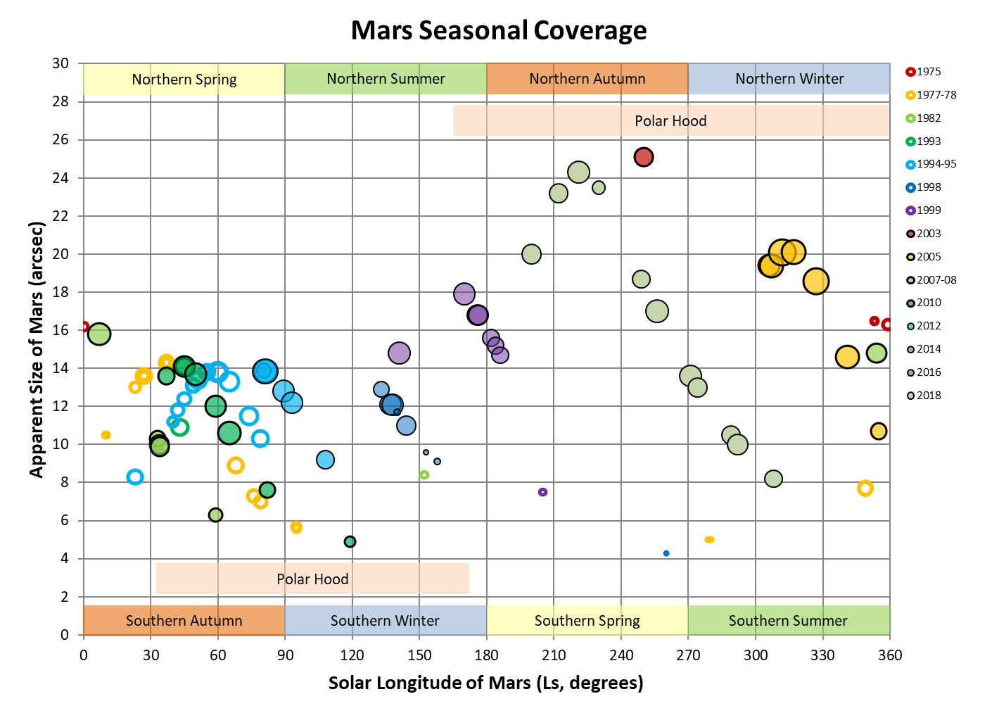

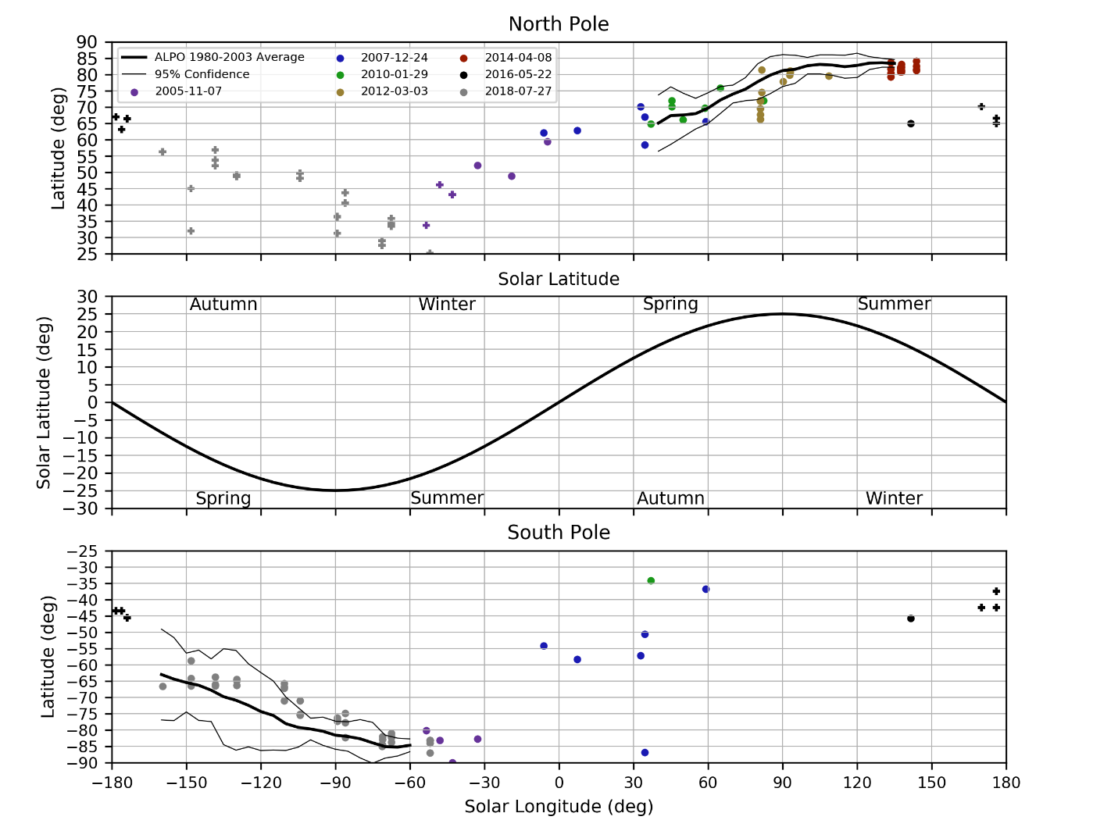

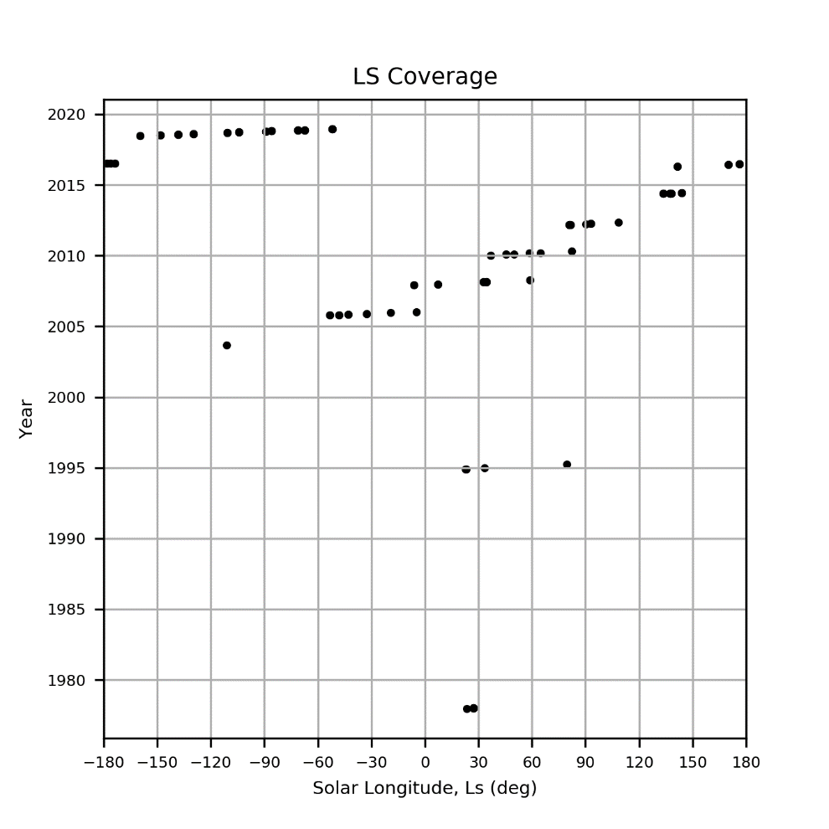

### Jupiter

Last Updated 4/02/2018

TBD

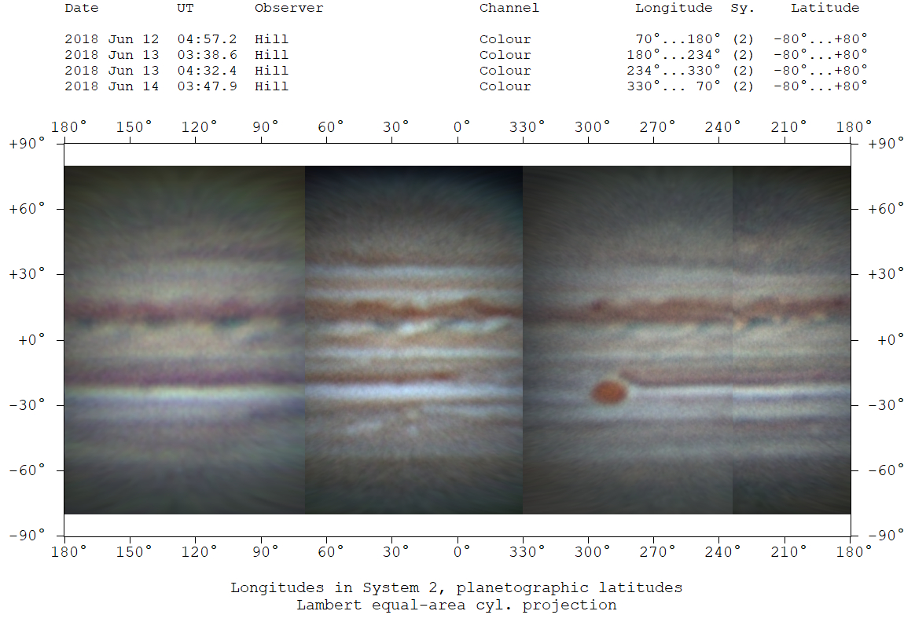

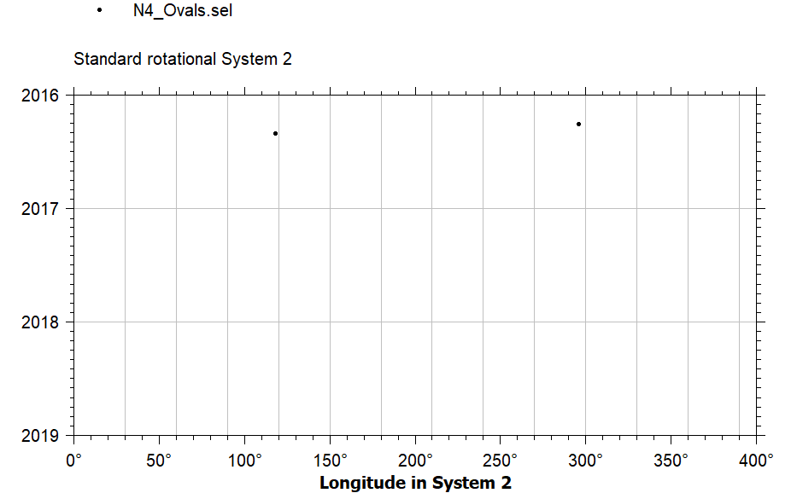

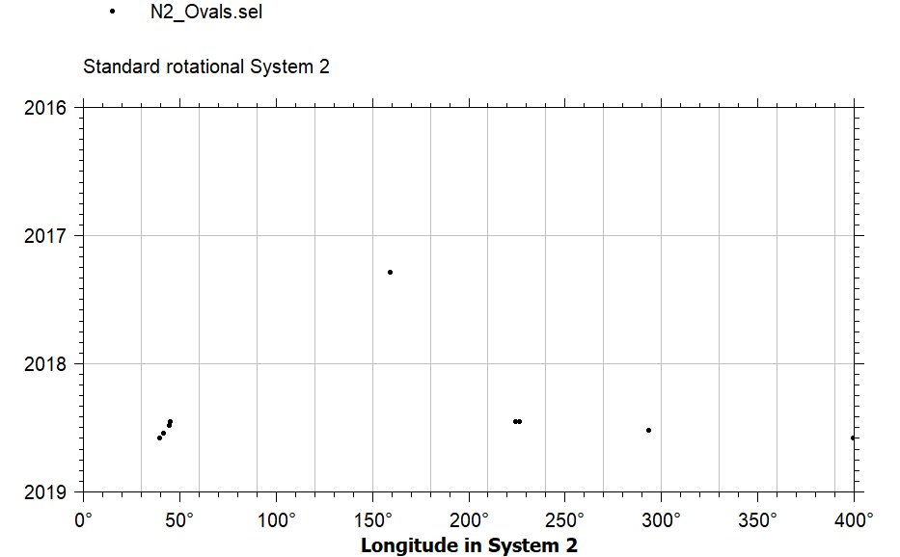

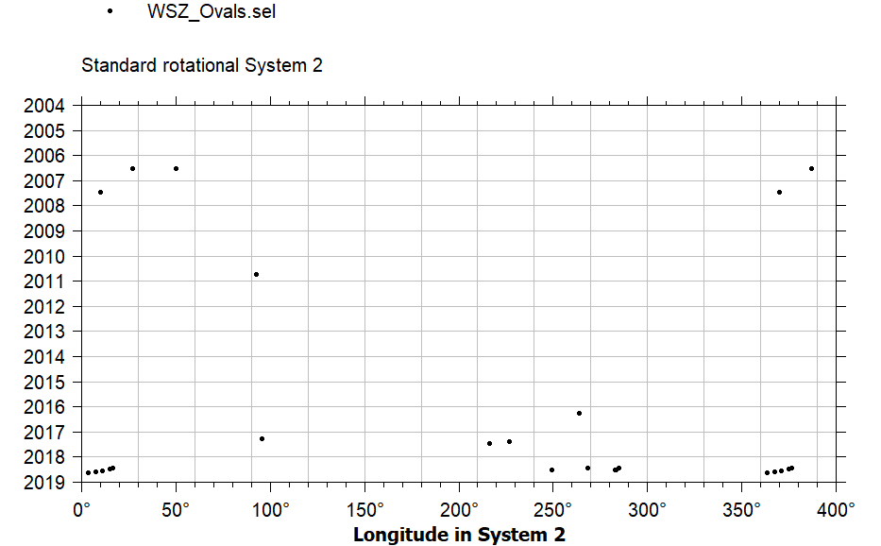

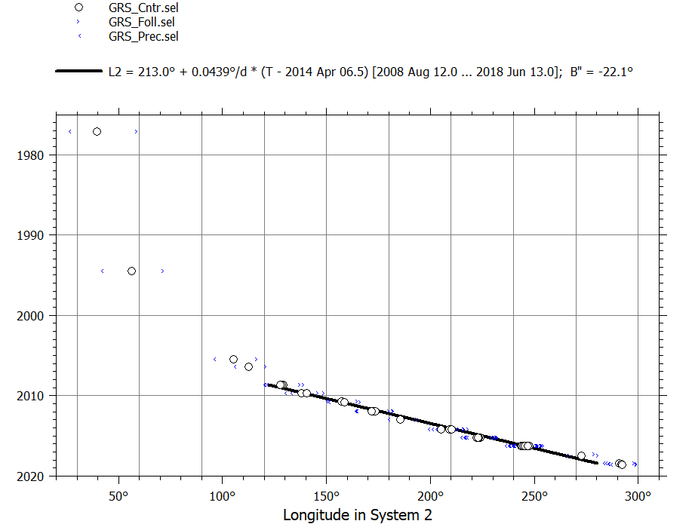

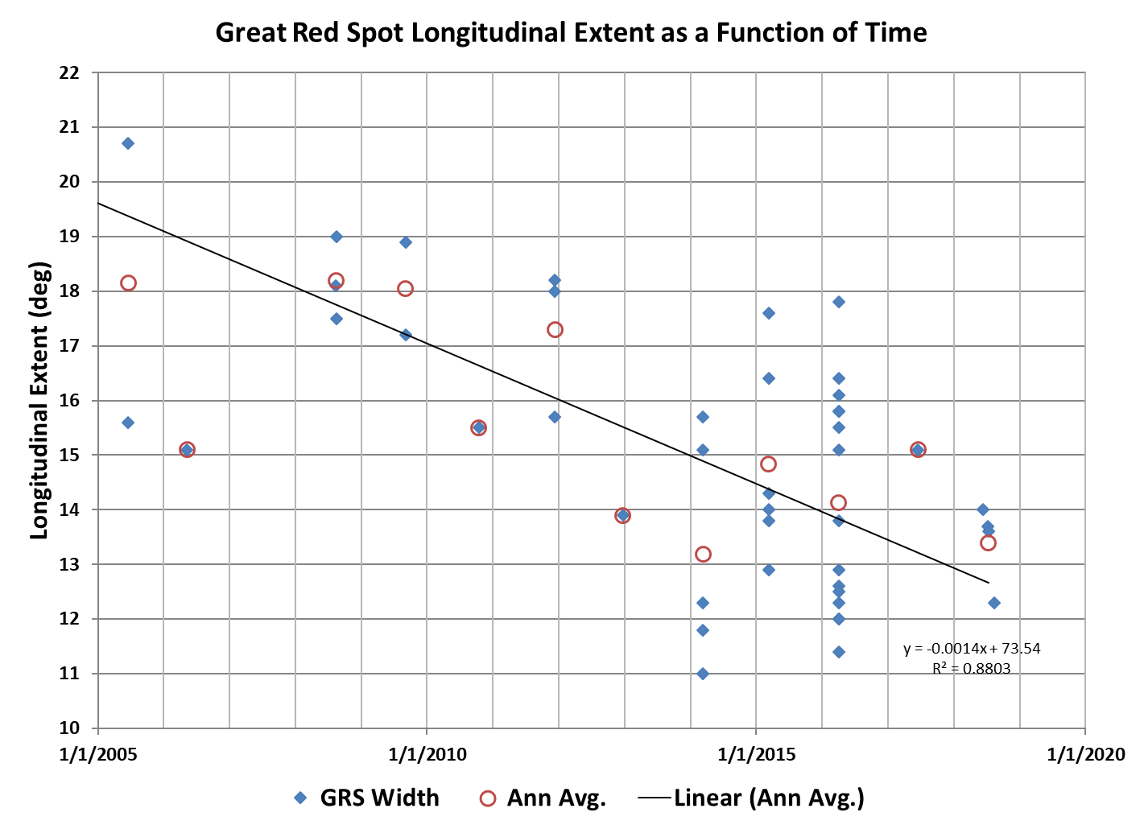

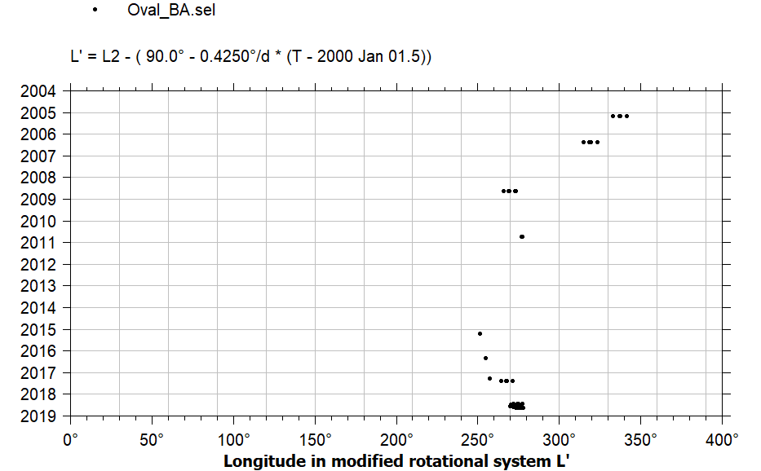

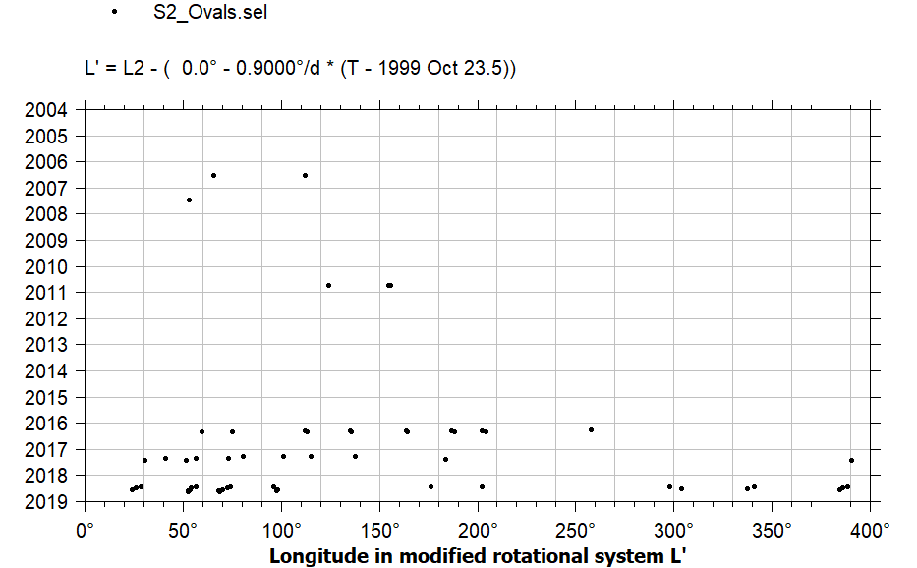

The modified rotational system is based on the one used in WinJUPOS drift charts for 2017-2018. There is weirdness between A1 and A8...A7, or maybe even A6. This is evident in the August 13UT data and I believe also in the

S4 Ovals 60S latitude.

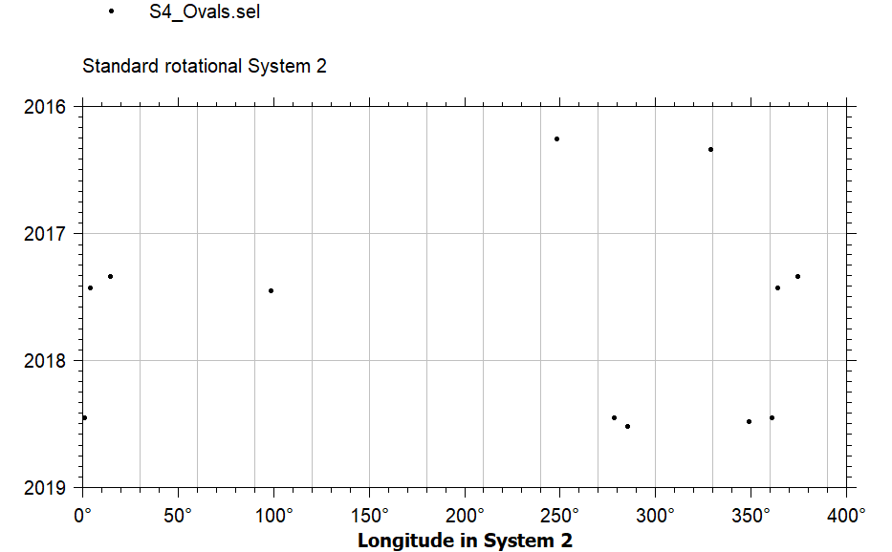

### Saturn

Last Updated 4/02/2018

TBD

## References

Charlebois, M., L. Drissen, A.-P. Bernier, F. Grandmont, and L. Binette (2010), A Hyperspectral View of the Crab Nebula, *The Astronomical Journal*, *139*, 2083-2096.

Charlebois, M., Drissen, L., Bernier, A.-P., Grandmont, F., & Binette, L. (2010). A Hyperspectral View of the Crab Nebula. *The Astronomical Journal, 139*, 2083-2096.